ECE 4999 Independent Study - B Term 2017



PRESSURE ULCER PREVENTION SYSTEM

An Independent Study Project submitted to the faculty of Worcester Polytechnic Institute

in partial fulfillment of personal interest for the Degree of Bachelor of Science in

Electrical Engineering

October 16, 2017

____________________

Shanshan Xie

Approved by:

____________________

Professor John McNeill, Advisor

Table of Contents

List of Figures 1

List of Tables 3

1 Introduction 4

1.1 Objective 4

1.2 Problem Statement 4

1.3 Goals 4

1.3.1 Time-Based Measurement 4

1.3.2 Force Sensing Resistor Array 5

1.3.3 Force Sensing Resistor Creep Exploration 5

2 Background Researches 5

2.1 Pressure Sores Formation 5

2.2 Pressure Ulcer Prevention 8

2.3 Time Based Measurement 9

2.4 RC Circuit 10

2.5 Microcontroller 12

2.6 The Inverter 13

2.6.1 Inverter with Tri-State Output 14

2.6.2 Inverter Switching Point 15

2.7 Dynamic Power Consumption 16

2.8 Real-Time Clock 17

2.9 Stress and Strain 17

2.10 Young’s Modulus 18

2.11 Piezoresistivity 19

2.12 Quantum tunneling 20

2.13 Creep Behavior Literature Reviews 22

2.13.1 Calibration of Force Sensing Resistors for Static and Dynamic Applications 22

2.13.2 Methodology 22

2.13.3 Creep Experiment 26

2.14 FSR Calibration Technique 28

2.15 Piezoresistance Time Dependence (Zhang, Pan, Zheng, & Yi, 2000) 29

2.16 Creep Modeling Literature Reviews 32

2.16.1 A New Approach for Modeling Piezoresistive FSR 32

3 Design Approaches 33

3.1 Objective 33

3.2 Microcontroller Parameters 33

3.3 Preliminary Design 34

3.4 Error Analysis 36

3.4.1 Mathematical Computation 36

3.4.2 MATLAB Simulation 38

3.4.3 Conclusion 40

3.5 Microcontroller Implementation 41

3.5.1 Programming Thoughts Behinds the Code 42

3.5.2 Delta T Exploration – Triangle Wave Input Experiment 44

3.5.3 Frequency Sweep for Threshold Voltage Verification 46

3.5.4 Capacitor vs Error Experiment 51

3.5.5 Resistor RFSR vs Error and RFSR vs Measurement Time Experiments 52

3.6 Error Simulation & System Implementation 54

3.6.1 Purpose 54

3.6.2 Experiment Procedures 54

3.6.3 Experiment Results 55

3.7 Further System Implementation 58

3.7.1 Purpose 58

3.7.2 Experiment Procedures 58

3.7.3 Experiment Results 59

3.8 Creep Behavior 60

3.8.1 Purpose 60

3.8.2 Experiment Procedures 60

3.8.3 Experiment Results 61

4 Conclusion 64

References 65

5 Appendices 67

5.1 MATLAB Code of Error Analysis Simulation 67

5.2 MATLAB Code of Delta Time Experiment 68

5.3 MATLAB Code of Capacitor vs Error Experiment 68

5.4 MATLAB Code of Resistor vs Error and Measurement Time 71

5.5 Code Composer Studio Code for System Implementation 74

5.6 Creep Behavior Experiment MATLAB Code 78

# List of Figures

Figure 1.1: Block diagram of the pressure ulcer prevention system (Agdeppa, Hussasin, Kim, & Loehle, 2017) 4

Figure 2.1: At-Risk Area of Pressure Ulcers Development (Reference: Bedsores (Decubitus…) 6

Figure 2.2: (a-d) Various Stages of Pressure Ulcer. (Bhattacharya & Mishra, 2015) 7

Figure 2.3: System Block Diagram with Time-Based Resistance Measurement (McNeill et al., 2016) 9

Figure 2.4: RC Circuit Diagram 10

Figure 2.5: RC Charging Curves (RC charging circuit tutorial & RC time constant. 2013) 11

Figure 2.6: The CMOS Circuit Diagram and Symbol 13

Figure 2.7: Tri-State Inverter Circuit Diagrams and Symbol 14

Figure 2.8: Transfer Characteristics of The Inverter Showing the Switching Point (Baker, 2010) 15

Figure 2.9: Stress Description 17

Figure 2.10: Strain Description 18

Figure 2.11: Piezoelectric Effect Example 19

Figure 2.12: Piezoelectric Effect Principle Demo 19

Figure 2.13: Change of Demension when Stress Applied 20

Figure 2.14: Energy Band Diagram 20

Figure 2.15: Energy Band Diagram 21

Figure 2.16: Energy Band Diagram 22

Figure 2.17: FSR With and Without a Resin Dome 23

Figure 2.18: Components of the Calibration and Data Acquisition System 24

Figure 2.19: FSR 400 Series Data Sheet 25

Figure 2.20: (a) Constant Weight Test. (b) Force Vs. Voltage Obtained with the Arithmetic Mean of The Previous Data. 26

Figure 2.21: Creep Issues in the Paper 27

Figure 0.3: (a)Voltage vs Time Plot (b)Values of The Voltage Derivative with Variation of the Load and Unload Velocity 27

Figure 0.4: Result Obtained When the Derivate Criteria Was Implemented To Eliminate Creep 28

Figure 0.5: Circuit Configuration 29

Figure 0.6: Schematic View of The Piezoresistance Measurement and Microstructure of The Conductor Filled Polymer Composites 30

Figure 3.1: Preliminary Design 34

Figure 3.2: Expected Output Behavior 35

Figure 3.3: RC Charge and Discharge Diagram with Error 36

Figure 3.4: Calculated Error with Respect to Force Sensitive Resistor from 1kΩ to 100kΩ. 38

Figure 3.5: MATLAB Simulation Flowchart 39

Figure 3.6: Simulated Error with Respect to Force Sensitive Resistor from 1kΩ to 100kΩ 39

Figure 3.7: Simulated and Calculated Error with Respect to Force Sensitive Resistor from 1kΩ to 100kΩ 40

Figure 3.8: The Updated Circuit Diagram after Implementing in Microcontroller 41

Figure 3.9: Microcontroller Flowchart 43

Figure 3.10: RTC Clock Frequency 44

Figure 3.11: Triangle Wave Experiment Waveform Characteristic 44

Figure 3.12 a&b: ∆t Computation 45

Figure 3.13: ∆t Experiment Result 46

Figure 3.14: Oscilloscope Waveform for f=140Hz to f=1000Hz 47

Figure 3.15: Frequency Sweep for Interrupt Trigger Voltage Exploration 47

Figure 3.16 a&b: Oscilloscope Waveform at (a)1.5kHz and (b)2kHz 48

Figure 3.17: CMOS Circuit Model for Prorogation Delay 49

Figure 3.18: Low to High Propagation Delay Due To The Paracitic Capacitor 49

Figure 3.19: The CMOS Inverter Switching Characteristic using the Digital Model 50

Figure 3.20: Clock Signal and Interrupt Response 50

Figure 3.21: Experimental and Simulation Data: Error vs Capacitance 52

Figure 3.22: Experiment and Simulation for Error and Measurement Time over Different Resistors RFSR 54

Figure 3.23: Error Experiment Results 56

Figure 3.24: System Implementation Experiment Results 57

Figure 3.25: Scope Picture of System Implementation 57

Figure 3.26: Implementation Flowchart 58

Figure 3.27: Implementation Flowchart 58

Figure 3.28: Updated Implementation Flowchart 59

Figure 3.29: Experiment Results for System Implementation 60

Figure 3.30: R/R0 vs t Best Fit Curve Results 62

Figure 3.31: R vs Time MATLAB Results 63

# List of Tables

Table 2.1: Tri-State Inverter Truth Table 14

Table 2.2: Common Metals Work Function 21

Table 2.3 FSR Sensor Details 23

Table 2.4 Thick Dome Details 23

Table 3.1 CC2650 Critical Parameters for the Time-Based Measurement 33

Table 3.2: Summary of Power Dissipation and Capacitor Needed for 1%, 0.1% or 0.01% Error 40

Table 3.3: Digital I/O Pins Configuration 42

Table 3.4: Error vs Capacitor Data Example 51

Table 3.5: Choice of C1, C2, RREF1, RREF2 55

Table 3.6: Experiment Procedures 59

Table 3.7: Weight to Stress Table 61

Table 3.8: A, B and N Parameter Prediction 61

Table 3.9: R0 Prediction 62

# Introduction

## Objective

The purpose of this chapter is to introduce the problem remaining in the existing pressure ulcer prevention system and explain the aims and purposes of this ongoing project.

## Problem Statement

The prevalence of pressure ulcers has been a critical issue affecting approximately 3 million adults (Eckman, 1989). The Electrical and Computer Engineering department and Biomedical Engineering department has been working on developing an innovative pressure ulcer prevention system with a plastic surgery at University of Massachusetts Medical School. previous Pressure Ulcer Prevention Major Qualifying Project(MQP) team converted the existing wired pressure ulcer prevention system into a wireless system which can monitor pressure and temperature at known at-risk locations and can transmit data into a computer. Particularly, the previous MQP team implemented a voltage based measurement for resistive force sensor using the voltage divider configuration (Agdeppa, Hussasin, Kim, & Loehle, 2017), as depicted in Figure 1.1. Ideally, under the configuration in Figure 1.1, the ADC output depends on the battery voltage VDD, since VDD not only provides the ADC reference but also provides a reference to the voltage divider. In reality, however, the change of VDD value has different effects on the ADC and on the voltage divider output Vp. Because of this dependency, the determined RFSR is inaccurate.

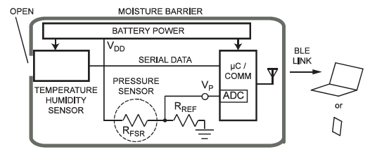

Figure 1.1: Block diagram of the pressure ulcer prevention system (Agdeppa, Hussasin, Kim, & Loehle, 2017)

## Goals

### Time-Based Measurement

An accurate measurement of pressure sensors is needed. That’s where the team’s project comes in: unlike the traditional voltage-based measurement technique, the time-based measurement for pressure ulcer prevention system relies upon the charge time of a capacitors and resistors system. Different than the voltage-based technic, this method fully isolates the battery influence on the resistor determination and requires no reference voltage or analog-to-digital converter, which is more digital-friendly by moving measurement into the time domain. In our case, an accurate RFSR value can be calculated purely depending on the time ratio under different RC combinations. The principle of RC circuit and some literature researches of time-based measurement method will be discussed in the following section.

### Force Sensing Resistor Array

After the time-based measurement is developed, the team will switch the focus to developing a 8 by 8 array of force sensing resistor. The purpose of using two-dimensional measurements were to enhance the resolution and increase the sensing area. As the goal, the matrix will be use the identify the high-risk area for detecting the pressure ulcer and identify the applied force for every sensor in the array.

### Force Sensing Resistor Creep Exploration

Viscoelasticity is concerned with materials which exhibit strain rate effects in response to applied stresses. These effects are manifested by the phenomena of creep under constant stress and stress relaxation under constant strain. In the research, the team experienced the creep issue when using the force sensing resistor, which is also called Piezoresistivity effect. The piezoresistive effect is a change in the electrical resistivity of a semiconductor or metal when mechanical strain is applied and it is similar to the piezoelectric effect. In this case, a prediction model for the time dependent behavior of the piezoresistance under pressure is investigated and the goal is to explore the relationship between electrical resistance and force applied to the piezoresistive force sensor. Once the team have the model of theoretical formulation, the team will be able to further calibrate the sensor to perform a more precise measurement.

# Background Researches

## Pressure Sores Formation

Pressure sores, also called bed sores or decubitus ulcers, are damaged skin regions when there is an unrelieved pressure on the skin. The at-risk locations happen in the area where the bones are close to the skin. The areas will change depending on the position that the patient applies. For example, when the patient is in the supine position (see the first position in Figure 2.1), the heel, tailbone, elbow, shoulder, and back of the head are the most at-risk locations. When the patient is lying in the left lateral recumbent position (see the second position in Figure 2.1), the most at-risk areas are ankle, knee, hip, shoulder, and ear. At last, the patient who uses wheelchair (see the sitting position in Figure 2.1) most likely has a high risk of developing pressure scores at shoulder blade, buttocks, heel, and ball of the foot.

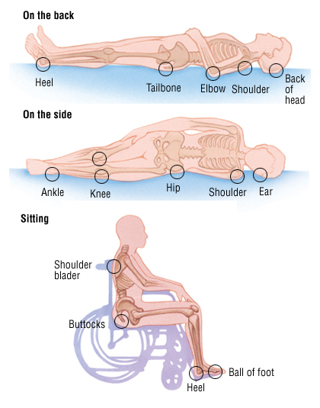

Figure 2.1: At-Risk Area of Pressure Ulcers Development (Reference: Bedsores (Decubitus…)

Pressure ulcers develops in four stages. In the first stage, the affected area of skin starts to look red in white people, and purple or blue in people with darker colored skin (Figure 2.2a). The skin may hurt or itch at this stage, but the pressure ulcer will not turn white when pressure is placed on them. The characteristics in stage one are:

* Non-blanchable erythema of intact skin can be difficult to assess in patients with darkly pigmented skin.
* Oedema, induration.
* Warmth over a bony prominence.
* When an eschar is present, accurate staging is not possible.

In the second stage, the affected skin area may be painful and the skin around it will be discolored because some of the outer surfaces of the skin or the deeper layer of skin are damaged (Figure 2.2b). When it comes to the stage three, the tissue below the skin starts to get damaged and skin loss occurs throughout the entire thickness of the skin, but the bone and muscle beneath the surface are intact (Figure 2.2c). The full thickness skins involving damage to or necrosis of, subcutaneous tissues may extend down to the underlying fascia. This lead to the stage four where the skin is severely damaged and the surrounding tissue begins to die (tissue necrosis). The underlying muscles, bone or joint which are still intact in stage three, may also be damaged, as shown in Figure 2.2d (Bhattacharya & Mishra, 2015). As a summary, constant pressure to the at-risk area compresses the blood vessels, which is the main supplier of oxygen and vital nutrients to the skin. Without enough blood flow, the pressure sores can be formed on the skin, because the skin cell eventually dies. Furthermore, pressure sores can permanently disrupt or destroy vital tissue underneath the skin, which leads to stage four of pressure ulcer formation, the most severe type of pressure ulcer.

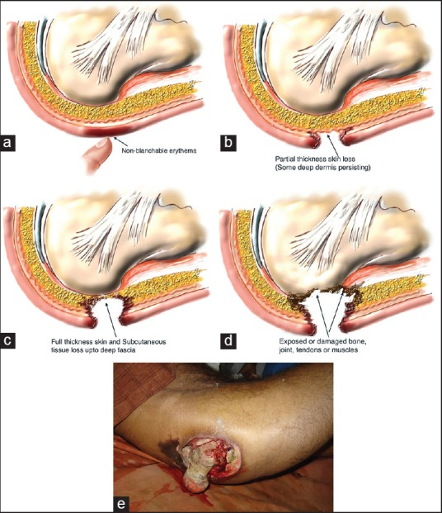

Figure 2.2: (a-d) Various Stages of Pressure Ulcer. (Bhattacharya & Mishra, 2015)

## Pressure Ulcer Prevention

As discussed in the previous section, there are four critical factors contributing to the development of pressure ulcers: pressure, shearing forces, friction, and moisture. When the body doesn’t get enough movement, it can hinder adequate blood flow to the skin. Thus, some preventions of the bed sores are needed. According to (5 tips for preventing bed sores in bedridden patients. 2015), the following list shows 5 tips for preventing ulcer pressure.

1. *Change positions frequently* - It is a good idea to reposition patients’ body at least every couple of hours. For example, if you have been lying on your back for a while, turn to the other side. There might be some patients that cannot turn by their own. In this case, a family member or caregiver need to help them to switch the position.
2. *Keep skin clean and dry* - The cleaner and drier people’s skin is, the less likely it will develop bed sores. Dip a wash rag in a bucket of warm water and mild soap and clean the skin with it.
3. *Use pillows* - National Institutes of Health (Preventing pressure ulcers: MedlinePlus medical encyclopedia) recommends placing a pillow under the tailbone, shoulders, heels and elbows. If people are lying on the side, it is better to put the pillow between their knees and ankles.
4. *Exercise* - Performing a few range of motion exercises in bed can help reduce the risk of bed sores.

Furthermore, pressure is now viewed as the single most important etiologic factor in pressure ulcer formation. There are many pressure relief system for the ulcer pressure. According to (Preventing pressure ulcers: MedlinePlus medical encyclopedia), the RENAISSANCE® Mattress Replacement System is used for the immobile patient who lies supine on the bed, the stretcher, or operating room table. It develops three separate cells that are not interconnected. In this case, deflation of each individual cell will reach a ZERO PRESSURE® during each alternating pressure cycle.

Another advanced pressure ulcer prevention is the ALTERN8 seating system. This system provides pressure relief in certain regular period. Additional to this feature, it can simulate the blood flow to skin areas while people are seated. By offering the combination of pressure relief therapy and an increase in blood flow, the ALTERN8 reportedly creates an optimum pressure ulcer healing environment.

The third technique that mentioned is a passive standing powered wheelchair that allows users to achieve a passive standing position. By using passive standing technique, reduction of seating pressure, decreased bone demineralization, increased blander pressure and lots of other great advantages can be achieved.

However, the cost of caring for these preventable pressure ulcers may now be as high as $60,000 per patient (Preventing pressure ulcers: MedlinePlus medical encyclopedia). This is the reason why an inexpensive and accurate pressure ulcer sensors are needed. And this is where our project comes into the game.

## Time Based Measurement

An interfacing technique for resistive force sensors using a time-based measurement approach in a biomedical sensor has been explored (McNeill et al., 2016). In this paper, they discussed using a 555 timer to accomplish the time-based measurement goal. Figure 2 shows the time-based resistance measurement technique, based on the LM555 timer. For the output digital waveform DCLK, the frequency f and duty cycle δ = TH/T (fractional “high” time TH relative to the waveform period T) are given by

|  |  |
| --- | --- |
| $$f=\frac{1.44}{\left(R_{A}+2R_{B}\right)C} δ=\frac{R_{A}+R_{B}}{R_{A}+2R_{B}}$$ | (1) |

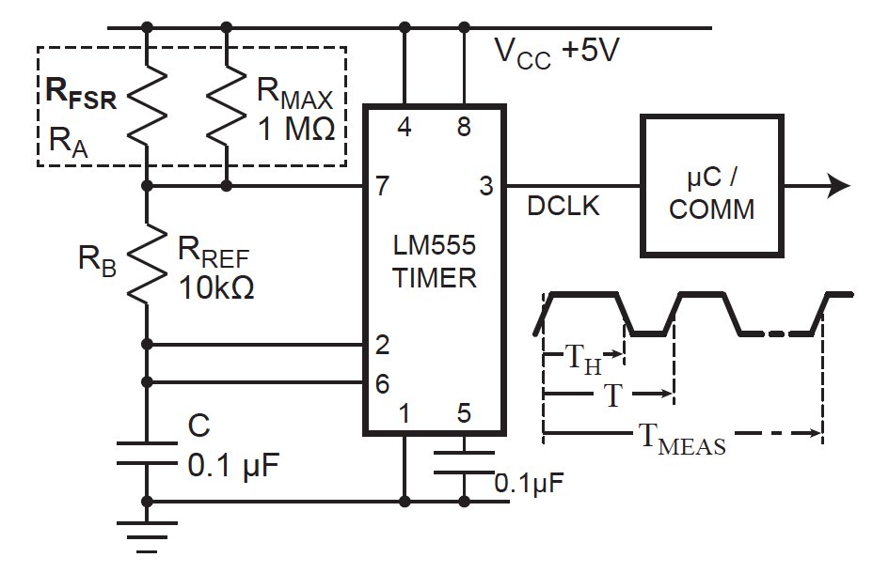

Figure 2.3: System Block Diagram with Time-Based Resistance Measurement (McNeill et al., 2016)

The design of Figure 2.3 was tested for accuracy over forces corresponding to a pressure range of 20 to 350 mm Hg. To investigate tolerance of this approach to variation in the FSR characteristic, four different sensors were tested. Measured results show an accuracy of 3% after calibration. Although presented in the context of a resistive pressure sensor, the technique is applicable to any resistive sensor (McNeill et al., 2016).

## RC Circuit

An RC circuit, shown in Figure 2.4, is formed by connecting a resistor in series with a capacitor. While a voltage pulse is applied to the circuit, the capacitor will charge up gradually through the resistor. The circuit response time is usually not represented in seconds or some absolute time. It is, however, expressed in time constants Tau. The general expression we used to calculate the voltage with respect to time is

|  |  |
| --- | --- |
| $$V_{c}\left(t\right)=V_{F}-(V_{F}-V_{I})e^{{-t}/{RC}}$$ | (2) |

where Vc(t) is the capacitor voltage with respect to time, VF is final voltage, VI is initial voltage. Because the capacitor are able to store electric energy, it can release and or hold the energy, depending on the voltage source. When the voltage increase from 0V to Vs, the capacitor draws a charging current and charges up. In this case, the final voltage is Vs and the initial voltage is 0V. On the other hand, when the voltage decrease from Vs to 0V, the capacitor releases electrons and discharges. In this case, the final voltage is 0V and the initial voltage is Vs. (see Figure 2.5).

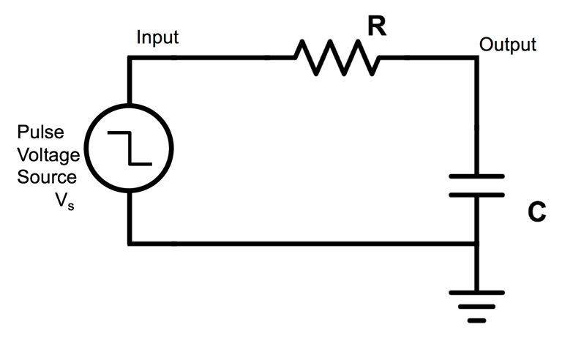

Figure 2.4: RC Circuit Diagram

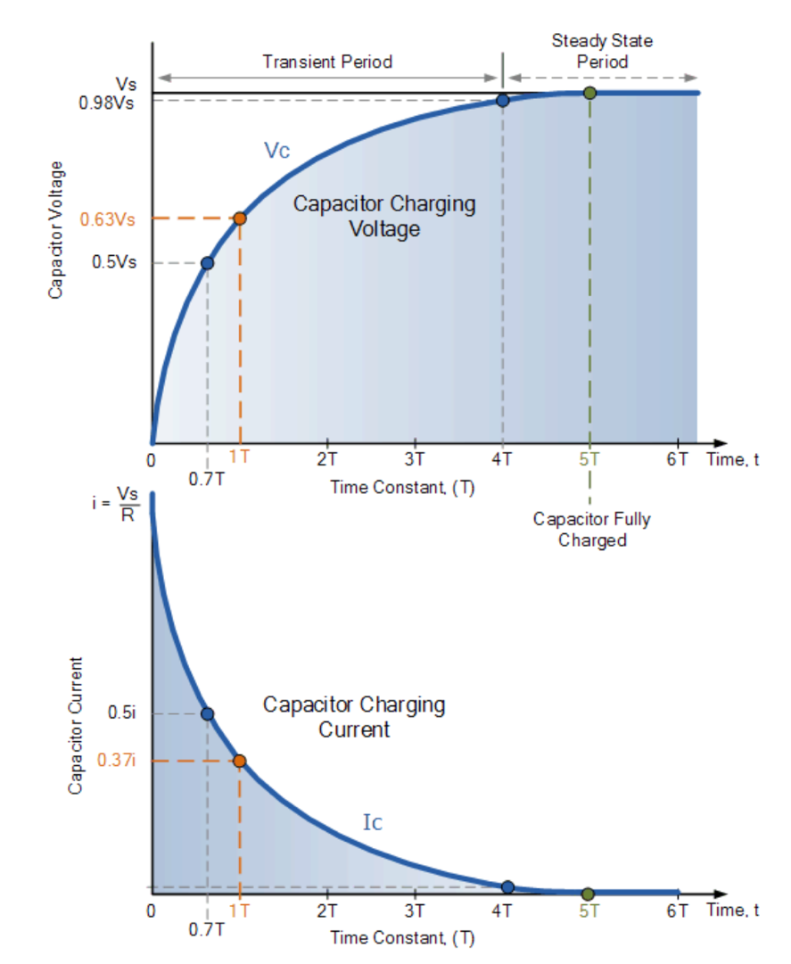

Figure 2.5: RC Charging Curves (RC charging circuit tutorial & RC time constant. 2013)

The voltage and current equations for charging a capacitor are

|  |  |
| --- | --- |
| $$V_{c_CHARGING}\left(t\right)=V_{F}-V_{F}*e^{{-t}/{RC}}$$ | (3) |
| $$I_{c_CHARGING}\left(t\right)=I_{0}*e^{{-t}/{RC}}$$ | (4) |

The RC in the above equations is called the time constant and τ is the symbol for the time constant. As Figure 2.5 shown, after one time constant, the voltage across the capacitor is 63% of the final voltage under any pair of resistor and capacitor. For four time constants, the voltage across the capacitor is 98% of the maximum voltage. And at 5 time constant, the capacitor will be considered fully charged and the voltage across the capacitor is 99.3% of the maximum voltage. The same idea also applies to the current characteristic in another direction, because the current goes down when the voltage increases.

Specifically, the time, usually called delay’s time, it takes the output to reaches 50% of the maximum voltage is defined using

|  |  |
| --- | --- |
| $$\frac{V_{s}}{2}=V_{s}\left(1-e^{{-t_{d}}/{RC}}\right)→t_{d}≈0.7RC$$ | (5) |

where RC is equal to τ. It is fair to say that RC has a dominant role in controlling the charging time and discharging time. In this project, the team is going to utilize this feature of RC circuit to measure the RFSR.

## Microcontroller

The microcontroller is essentially a small computer integrated into a variety of packages and sizes. A personal computer typically run a series of tasks and programs simultaneously. For example, people are able to listen to music and open a browser at the same time. In the other hand, a microcontroller is dedicated to a single task, in our case, data processing of measuring applied pressure and transferring to mobile devices. Microcontroller, or MCU in short, has central processing unit inside that process all the calculations and logic operations in the background. It is this central processing unit that allows the programs to function properly. A microcontroller also has memory. The memory functions as a storage for useful information and programs. And the imperative part of the microcontroller is the system clock, which controls the speed that the central processing unit thinks and process the data. The clock is generated by an external or internal oscillator, like an engine in the vehicle. Without the engine, everything in the microcontroller will not function at all. A higher frequency, however, would consume more power in a linear behavior (see discussion in section 2.7). Some key parameters are listed in Table 3.1 for the team’s reference while contributing for the project.

## The Inverter

An inverter is a basic building block for digital circuit design. The right figure in Figure 2.6 presents the symbol that used to represent the CMOS inverter. As the left figure in Figure 2.6 shows, a CMOS inverter consists of a PMOS and NMOS by connecting the drain and gate of those two MOSFETs. The source of PMOS is connected to the power supply and the source of NMOS is connected to ground. With this configuration, when the input goes from low to high, let’s say from 0V to 5V, the NMOS will be turned on and the PMOS will be turned off, connecting the output to ground through the NMOS. Similarly, when input is low, output will be pulled to VDD through the PMOS device. Since it can perform the logic operation of $A$ to $\overline{A}$, people call it CMOS inverter (complementary MOSFET inverter).

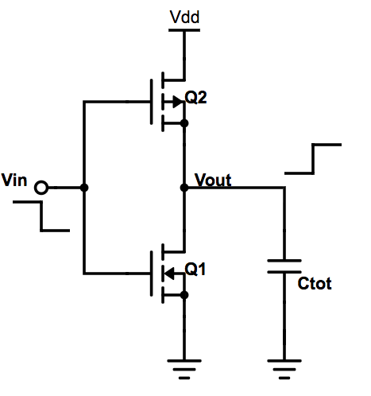 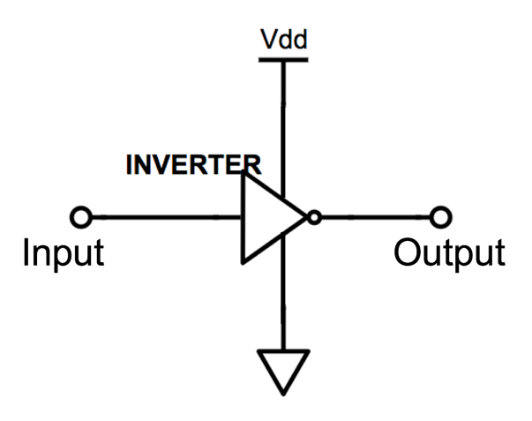

Figure 2.6: The CMOS Circuit Diagram and Symbol

### Inverter with Tri-State Output

In the digital world, tri-state logic is used to assume a high-impedance state in addition to the low and high logic levels for the output, effectively removing the output from the circuit. There are two configurations of the design of an inverter with tristate outputs, as the upper two figures in Figure 2.7 shows. It can be thought as a switch. A high on “En” pin allows the circuit to operate normally as an inverter, like closing a switch. A low on the “En” pin forces the output into the high-impedance state, like opening up a switch (Baker, 2010). The truth table can be found in Table 2.1. This circuit is useful for the team’s project by providing a high-Z to mimic the switch for the time-based RC configuration. Specifically, in CC2650 settings, by default, the I/O driver (output) and the input buffer (input) are disabled (tri-state mode) at power on and thus the I/O pin can safely be left unconnected (floating).

Table 2.1: Tri-State Inverter Truth Table

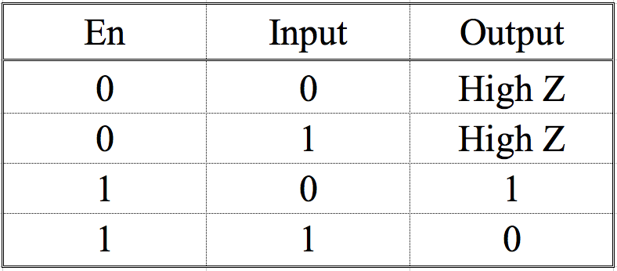

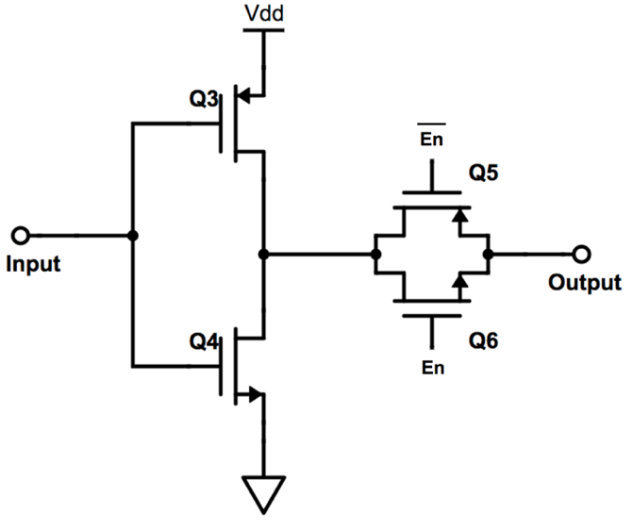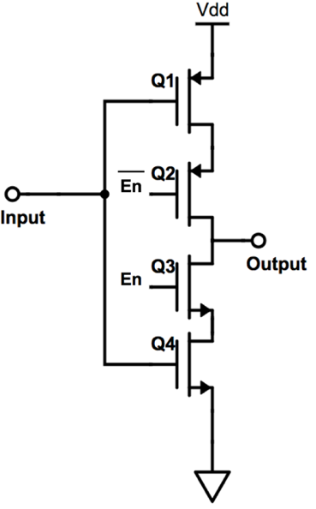

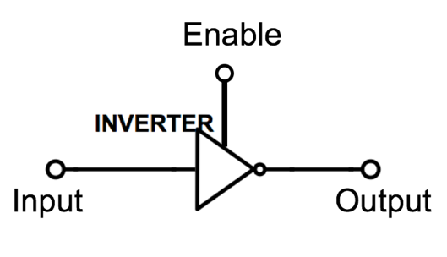

Figure 2.7: Tri-State Inverter Circuit Diagrams and Symbol

### Inverter Switching Point

Consider the transfer characteristics of the basic inverter as shown in Figure 2.8. Point C corresponds to the point on the curve when the input voltage is equal to the output voltage. At this point, the input or output voltage is called the inverter switching point voltage, VSP and both M2 and M1 is on and in the saturation region (Baker, 2010). The equation for VSP is given by the following equation:

|  |  |
| --- | --- |
| $$V_{SP}=\frac{\sqrt{{β_{n}}/{β_{p}}}*V_{THN}+(VDD- V_{THP})}{1+\sqrt{{β_{n}}/{β_{p}}}}$$ | (6) |

where ß is determined using

|  |  |
| --- | --- |
| $$β_{n}=KP_{n}(\frac{W_{n}}{L_{n}})$$ | (7) |

Therefore, the changes of the switching voltage partially depend on either width of MOSFET or length of MOSFET changes.

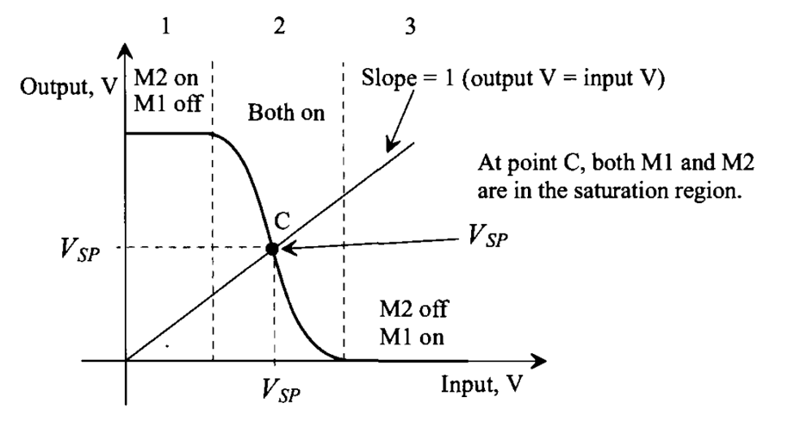

Figure 2.8: Transfer Characteristics of The Inverter Showing the Switching Point (Baker, 2010)

## Dynamic Power Consumption

Reducing the power consumption makes a wearable device more reliable. The requirements of 7 days’ battery longevity become a driving force for the team to investigate the dynamic power consumption from the microcontroller CC2650. Considering a CMOS circuit in the MCU, see Figure 2.6, when the output is high, connecting to VDD, the capacitor will start charging. The average current that flows in the circuit is

|  |  |
| --- | --- |
| $$I_{avg}=\frac{Q}{t}$$ | (8) |

where Q is given by the voltage applied to the capacitor times the capacitance, Q=C*V. And t is the capacitor charging time. Therefore,

|  |  |
| --- | --- |
| $$I_{avg}=\frac{C_{tot}*V_{DD}}{t}$$ | (9) |

where VDD is the supply voltage. The power consumption is given by the multiplication of average current and supply voltage

|  |  |
| --- | --- |
| $$P_{dym}=I_{avg}*V_{DD}$$ | (10) |

In this case, by combining Equation Iavg3 and 4, the dynamic power consumption is

|  |  |
| --- | --- |
| $$P_{dym}={V_{DD}}^{2}*C_{tot}*f$$ | (11) |

where f is the microcontroller clock frequency. In this case, CC2650 clock frequency is up to 48MHz. In terms of the parasitic capacitor, according to page 340 (Baker, 2010), Ctot is typically around 5fF. The total power is the addition of the dynamic power dissipation and the static power dissipation. However, in the CMOS invert, the static power dissipation is practically zero (Baker, 2010). Therefore, in the project, the team mainly takes the dynamic power dissipation into account.

## Real-Time Clock

A real-time clock, RTC in short, is a computer clock that keeps track of the current time (Real-time clock (RTC).2005). It is usually battery-powered in a separate power source. Using the RTC has several benefits as listed below.

1. Low power consumption
2. Free the main system for time-critical tasks
3. More accurate than other methods.

Separated from the microprocessor, which operates under CPU clock, the RTC uses a small memory on its microchip to store system description or setup values – including current time values stored by the real-time clock. When the microprocessor is turned on, the Basic Input-Output Operating System (BIOS) that is stored in the read-only memory (ROM) microchip reads the current time from the memory in the chip with the real-time clock (Real-time clock (RTC).2005).

Most people will be confused about the difference between the CPU clock and the real-time clock, the team did confuse about this at the beginning. According to the (Difference between system clock and real time clock. 2016), the processor relies on a small quartz crystal circuit called the system clock to control the timing of all operations. While RTC or Real Time Clock is the form of an integrated circuit which is used to keep tracks of current time. Particularly, the team utilized the RTC in the microcontroller to keep tracks on the start and stop time of charging stages of the capacitor.

## Stress and Strain

Stress measures the force per unit area applied to an object. To find stress, divide the amount of force applied to the object by the cross-sectional area of the object you are applying the force to. The units used to measure stress are the same used to measure pressure, Pascals (or Pa). The equation and interpretation of stress as shown in Figure 2.9.

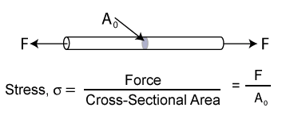

Figure 2.9: Stress Description

Some common measurements of stress are:

* Psi = lbs/in2 (pounds per square inch)
* ksi or kpsi = kilopounds/in2 (one thousand or 103 pounds per square inch)
* Pa = N/m 2 (Pascals or Newtons per square meter)
* kPa = Kilopascals (one thousand or 103 Newtons per square meter)
* GPa = Gigapascals (one million or 106 Newtons per square meter)

Strain is the response of a system to an applied stress (see Figure 2.10). When a material is loaded with a force, it produces a stress, which then causes a material to deform. Engineering strain is defined as the amount of deformation in the direction of the applied force divided by the initial length of the material. This results in a dimensionless number. For example, the strain in a bar that is being stretched in tension is the amount of elongation or change in length divided by its original length. As in the case of stress, the strain distribution may or may not be uniform in a complex structural element, depending on the nature of the loading condition.

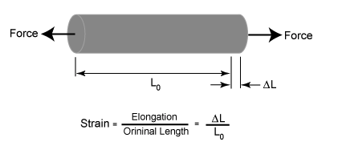

Figure 2.10: Strain Description

If the stress is small, the material may only strain a small amount and the material will return to its original size after the stress is released. This is called elastic deformation, because like elastic it returns to its unstressed state. Elastic deformation only occurs in a material when stresses are lower than a critical stress called the yield strength. If a material is loaded beyond its elastic limit, the material will remain in a deformed condition after the load is removed. This is called plastic deformation.

## Young’s Modulus

The Young's modulus of a material is a number that tells you exactly how stretchy or stiff a material is, a property known as elasticity. Materials like rubber have a very low Young's modulus, which means that they stretch a lot when you apply even a small force to them. Other materials, including metals like copper, are much stiffer and have a higher Young's modulus. They can still stretch if you apply a big enough force, but it takes a lot more force to stretch copper than a rubber band. Some materials, such as hard ceramics and diamonds, are even stiffer than metals and have an even higher Young's modulus.

The Piezoelectric Effect was discovered in the 1880’s and is used widely in a number of transducers and electronic gear (https://www.cosmic-energy.org/?page_id=771). It refers to a change in electric polarization that is produced in certain materials when they are subjected to mechanical stresses. For example, in Figure 2.11, the pressure is lead to light up the electric light bulb. Additionally, This stress-dependent change in polarization manifests as a measurable potential difference across the material. Referred to as the *direct piezoelectric effect*, this phenomenon is observable in many naturally available crystalline materials, including quartz, Rochelle salt, and even human bone. Engineered materials, such as lithium niobate and lead zirconate titanate (PZT), exhibit a more pronounced piezoelectric effect.

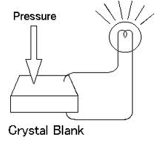

Figure 2.11: Piezoelectric Effect Example

An interesting figure that shows the principle of the piezoelectric effect is shown in . The piezoelectric effect causes crystal materials like quartz to generate an electric charge when the crystal material is compressed, twisted or pulled. The reverse also is true, as the crystal material compresses or expands when an electric voltage is applied.

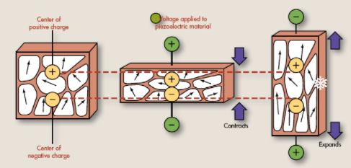

Figure 2.12: Piezoelectric Effect Principle Demo

## Piezoresistivity

The piezo-resistive effect describes the change in electrical resistance that occurs when an external force is applied to a semiconductor. This change only affects the material's electrical resistivity. Unlike the piezoelectric effect, it cannot be used to generate a voltage across the device. The strain from the applied force impacts the material's band structure, which makes it easier or more difficult for electrons to be excited into the conduction band. Consequently, the density of current carriers is altered and the material's resistance changes. As the resistance is related to the length and cross-sectional area, as shown in Equation 12, the change of relative dimensions (see Figure 2.12) will lead to the change of resistance.

|  |  |
| --- | --- |
| $$P_{dym}={V_{DD}}^{2}*C_{tot}*f$$ | (12) |

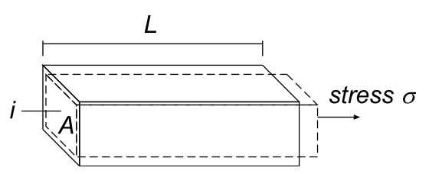

Figure 2.13: Change of Demension when Stress Applied

## Quantum tunneling

The tunneling current flows across the small gap that separates the tip from the sample, a case that is forbidden in classical physics but that can be explained by the better approach of quantum mechanics. There are two requirements for it to happen,

1. Small distance
2. Bias to allow net current to flow

In a metal, the energy levels of the electrons are filled up with a particular energy, known as the ‘Fermi energy’ EF. In order for an electron to leave the metal, it needs an additional amount of energy Φ, the so-called ‘work function’. Figure 2.14 depicts this stage graphically. Table 2.2 shows the common metals work function.

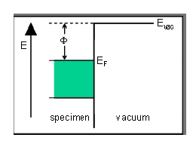

Figure 2.14: Energy Band Diagram

Table 2.2: Common Metals Work Function

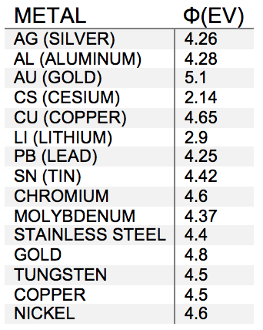

When the specimen and the tip are brought close to each other, there is only a narrow region of empty space left between them. On either side, the electrons are present up to the Fermi energy. They need to overcome a barrier Φ to travel from tip to specimen or vice versa, shown in Figure 2.15.

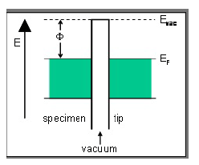

Figure 2.15: Energy Band Diagram

If the distance d between specimen and tip is small enough, electrons can ‘tunnel’ through the vacuum **barrier (Figure X).** When a voltage V is applied between specimen and tip, the tunneling effect results in a net electron current. And this is the tunneling current.

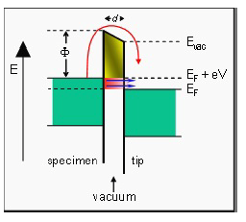

Figure 2.16: Energy Band Diagram

## Creep Behavior Literature Reviews

### Calibration of Force Sensing Resistors for Static and Dynamic Applications

This article shows a procedure to calibrate Force Sensing Resistors (FSR), whose manufacturers rarely offer calibration details. Literature and experience show that, due to the nature of FSR construction, its time dependency makes it hard to calibrate at first glance by simple measurements. The methodology employed is based upon the comparison of the measured data obtained from an FSR with the one obtained from a calibrated load cell. The force loading and unloading processes are performed automatically with a mechatronic device which allows having time-invariant and variant force profiles. In the article, a special analysis is taken over creep and hysteresis compensation along with its relationship with static and dynamic applications with the help of existing literature. At the end, a time-dependent function is obtained that relates the force applied on the sensor, and the signal obtained from it, allowing for the use on applications to measure force and pressure in ranges from 0 to 20N and 0 to 100mmHg respectively.

### Methodology

The details of the sensor are shown in Table 2.3. The electronic circuit configuration is recommended in the datasheet by the manufacturer, see Figure 2.19, for high resolution and low-value range measurements on dynamic applications. In the circuit configuration, FSR resistance value, system input, will be converted to an output voltage. In addition, this research followed the technique of (Ref: a technique for conditioning and calibrating force-sensing resistors…). Therefore, they attach a thick dome to the sensing area with a thin double-sided tape. The detail of the thick dome is shown in Table 2.4 and this thick dome can assist to evenly distribute the force applied to the sensor over its entire surface. Figure 2.17 shows the structure of the FSR sensor setup that this author used.

Table 2.3 FSR Sensor Details

|  |  |
| --- | --- |
| Type | Interlink Electronics 402 FSR |
| Sensing Area | 12.7mm diameter |
| Circuit Configuration | Voltage Divider |

Table 2.4 Thick Dome Details

|  |  |
| --- | --- |
| Area | 12.7mm diameter |
| Thickness | 3.3mm |
| Material | Fiberglass Resin |

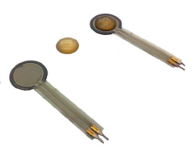

Figure 2.17: FSR With and Without a Resin Dome

They used LabVIEW software for data acquisition and a PCI 6013 data acquisition card (NI-DAQ). A perspective views they showed in the paper is shown in Figure 2.18.

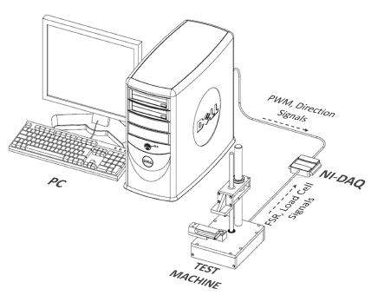

Figure 2.18: Components of the Calibration and Data Acquisition System

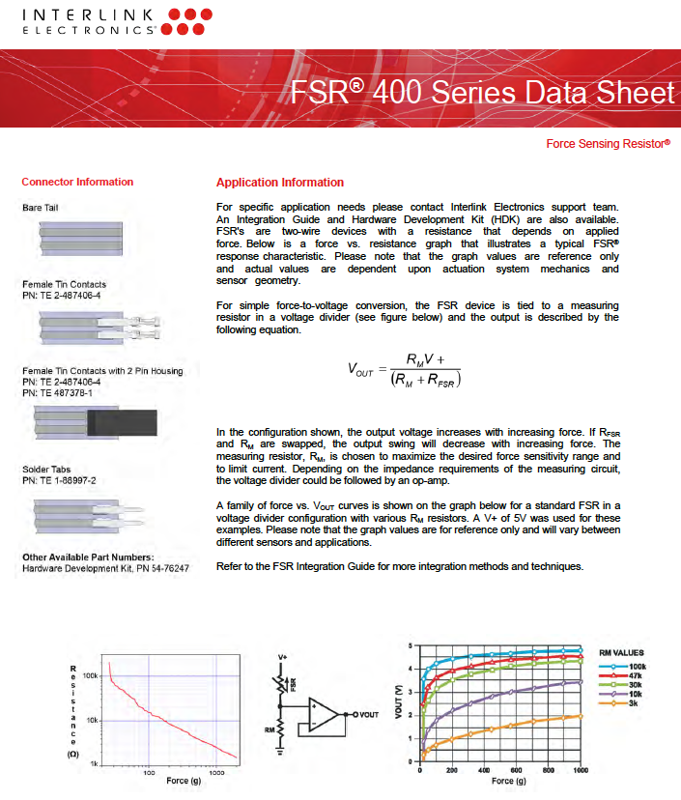

Figure 2.19: FSR 400 Series Data Sheet

### Creep Experiment

At the first stage in the experiment that the paper present, calibrated weights were statically placed over the sensor in order to obtain a relation between the applied force and the output voltage of the circuit. Figure 2.20 (a) shows that the voltage vs time data are discontinuous and discrete. The author also calculates the arithmetic mean value of voltage for each weight in order to obtain a Force vs. Voltage plot, shown in Figure 2.20 (b). All of the experiment showed the creep issue in the sensor (see Figure 2.21). In Figure 2.21, the force increases as time increase, which shows that the FSR resistance decreases in time.

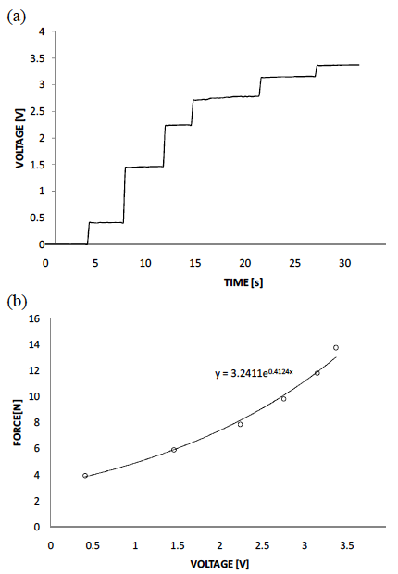

Figure 2.20: (a) Constant Weight Test. (b) Force Vs. Voltage Obtained with the Arithmetic Mean of The Previous Data.

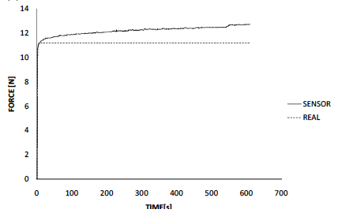

Figure 2.21: Creep Issues in the Paper

The author came up with a novel idea about calculating the derivative in time of the acquired voltage signals. Therefore, the derivative value will indicate the creep behavior. At the same time, it can determine if the increase signals are due to the creep or the actual increase in pressure. As shown in Figure XXXX, the derivative value increase when the load and unload velocity is increased.

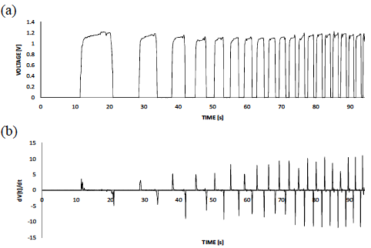

Figure 2.22: (a)Voltage vs Time Plot (b)Values of The Voltage Derivative with Variation of the Load and Unload Velocity

A statically placed weight test was performed to implement the derivative criteria for creep correction, with a 0.2V/s as the minimum value to recognize that a (V) change was in fact due to a change in the sensor’s load. The result obtained with this procedure, is shown in Figure 2.23. The algorithm modification consisted just on adding an if/else statement which ignores derivative values below 0.2V/s. Such creep behavior can be analogously compared with a sponge, which when it is firstly squeezed reduces its thickness a certain amount, but after a while, it would slowly continue reducing its thickness until reaching a certain limited value.

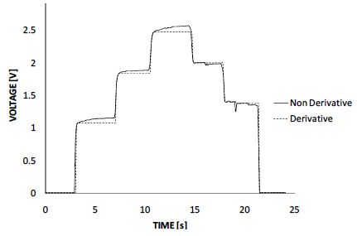

Figure 2.23: Result Obtained When the Derivate Criteria Was Implemented To Eliminate Creep

## FSR Calibration Technique

This article developed techniques to use inexpensive pressure-sensing to force-sensing devices. The effects of nonlinear response properties and dependence on loading history are compensated by signal conditioning and calibration. Different than the previous report, in this report, an active area of 5mm diameter FSRs was used. They also developed a thin layer of epoxy, in the shape of a dome. Because the dome was very rigid, it did not interfere with the sensitivity or dynamic response of the sensor to compressive force.

The circuit configuration used in this paper is shown in Figure 2.24. The author used an operational amplifier circuit so that the output can be made more linear over the desired range by adding a compensating resistor as shown in Figure 2.24. The output voltage is shown in Equation 13.

|  |  |
| --- | --- |
| $$V_{0}=V_{i}*\frac{Rd(Ra+Rb)}{Ra(Rc+Rb)}$$ | (13) |

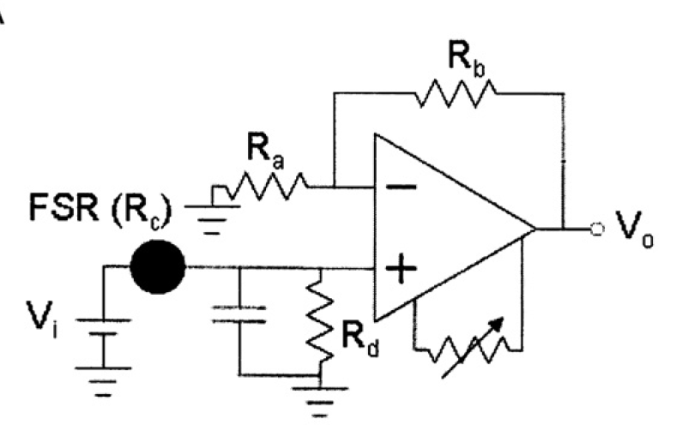

Figure 2.24: Circuit Configuration

## Piezoresistance Time Dependence (Zhang, Pan, Zheng, & Yi, 2000)

This report investigated the piezoresistance and its time dependence of conductor-filled polymer composites, which is highly related to the topic of the team’s B term experiment. To reveal the origin of the time dependence of piezoresistance, the creep of the polymer matrix is also studied. Based on the interparticle separation change under the applied stress, a model has been developed to predict the piezoresistance and its time dependence. By analyzing the model, the influences of applied stress, filler particle diameter, filler volume fraction, matrix compressive modulus, potential barrier height, and the matrix creep behavior on the piezoresistance and its time dependence are interpreted quantitatively. In the paper, the predicted results are compared with the experimental data obtained on the polymer composites filled with conductor fillers, and good agreements were obtained.

In conducting composites the total resistance is a function of both the resistance through each conducting particle and the polymer matrix. Assuming that the resistance of the matrix is constant everywhere, the resistance of the paths perpendicular to the current flow may be neglected, and, thus, the number of conducting particles between electrodes becomes a factor in this relationship, as well as the number of conducting paths [see Figure 1]. The total resistance can then be described by the Equation 14.

|  |  |
| --- | --- |
|  | (14) |

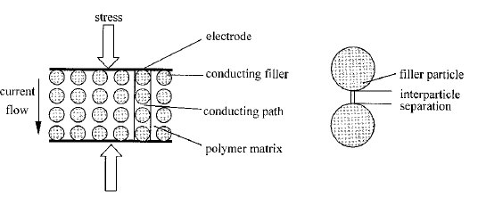

Figure 2.25: Schematic View of The Piezoresistance Measurement and Microstructure of The Conductor Filled Polymer Composites

where R is the composite resistance, Rm the resistance between two adjacent particles, Rc the resistance across one particle, L the number of particles forming one conducting path, and S the number of conducting paths. When the interparticle separation is very large, no current flows through the interparticle separation. But if the separation is quite little, the tunneling current may flow through the separation. 15 According to the analyses of Simmons, 16–19 the tunneling current J at low applied voltage is given by Equation 15.

|  |  |
| --- | --- |
|  | (15) |

where m and e are the electron mass and charge respectively, h Plank’s constant, V the applied voltage, s the thickness of the insulating film, and f the height of the potential barrier between the adjacent particles that can be gained by the subtraction of polymer’s work function from the conductor’s. Because the electron tunneling probability depends on the insulating barrier thickness, it is considered that practically all the tunneling occurs within the small surface areas.20 Thus, as shown in Figure 2.25, s in Equation XX equals the separation between the surfaces of two adjacent particles, which is the least distance between the particles.

Assuming that a2 is the effective cross-sectional area, where the tunneling occurs (see Figure 2.25), then the resistance Rm is given as follows:

|  |  |
| --- | --- |
|  | (16) |

where

|  |  |
| --- | --- |
|  | (17) |

Then substituting equation 16 and 17 into 14 gives

|  |  |
| --- | --- |
|  | (18) |

If a stress is applied to the sample, the resistance will be altered due to the change of interparticle separation, which is caused by the compressibility difference between the filler particle and matrix. Assumed that the interparticle separation changes from s0 to s under the applied stress, the relative resistance (R/R0) can then be calculated by

|  |  |
| --- | --- |
|  | (19) |

where R0 is the original resistance, and s0 the original interparticle separation. As the compressive modulus of the polymer matrix is much lower than that of conducting particle, the deformation of conducting particle under stress can be neglected. As a result, the change of interparticle separation along the conducting path is only due to the deformation of the polymer matrix. Therefore, if the applied stress is uniaxial press, the separation s under the applied stress can be calculated as

|  |  |
| --- | --- |
|  | (20) |

where ε is the strain of the polymer matrix, σ is the applied stress, and M is the compressive modulus of the polymer matrix. To simplify the arithmetic during the estimating of s0, the conducting particles are assumed to be spherical, of the same size, and arranged in a cubic lattice. Then the interparticle separation s0 is given by

|  |  |
| --- | --- |
|  | (21) |

where D is the particle diameter, and u the filler volume fraction. Substituting equation 20 and 21 into equations 19 gives

|  |  |
| --- | --- |
|  | (22) |

R0 is the initial resistance of the polymer composite, which can be measured by precise measurement techniques.

Besides the stress, the interparticle separation change of the polymer matrix is also a function of time, which can be interpreted by the creep of polymer.22 As a result, the piezoresistance of composites varies with time during the test. The deformation of the matrix can be perfectly described by the famous Nutting equation:

|  |  |
| --- | --- |
|  | (23) |

where ε0 is the original strain under the applied stress, ψ, β, and n are constants. The time dependence of interparticle separation under the fixed stress can then be calculated as

|  |  |
| --- | --- |
|  | (24) |

combining equation 21, 23 and 24 with equation 18, the relative resistance of composites at the time of t under the fixed stress can be expressed as

|  |  |
| --- | --- |
| $$\frac{R}{R_{0}}=\left(1-\frac{ψσt^{n}}{1-ε_{0}}\right)*exp⁡\{-γψσD[{\left(\frac{π}{6}\right)}^{\frac{1}{3}}θ^{-\frac{1}{3}}-1]t^{n}\}$$ | (25) |

## A New Approach for Modeling Piezoresistive FSR

This paper discussed the development of a model and a new theoretical formulation for predicting piezoresistive behavior in semiconductive polymer composites, including their creep behavior and constant resistance. The paper reviews the same formula that was proposed in Equation 22 in the last section. Instead of using the Nutting equation in Equation 23, the paper used a different model, shown in Figure 2.26, to develop the time dependence relationship.

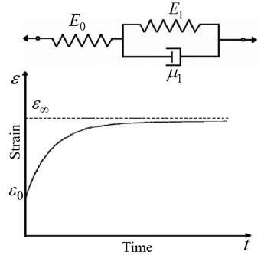

Figure . Three Parameters Solid Model and Creep Behavior of It

# Design Approaches

## Objective

The objective of the chapter is to present pre-design consideration, including current limit, error analysis, and circuit components determination, in this case, for resistors and capacitor. The chapter also provides some critical CC2650 microcontroller parameter for defining the design.

## Microcontroller Parameters

CC2650 is an ultra-low power wireless microcontroller. It supports Bluetooth, ZigBee, and 6LoWPAN and ZigBee RF4CE remote control application. Specifically, the team targeted on Bluetooth application for the pressure ulcers prevention system. Some of the key CC2650 parameters are collected to assist the further design analysis for the team (see Table 3.1).

Table 3.1 CC2650 Critical Parameters for the Time-Based Measurement

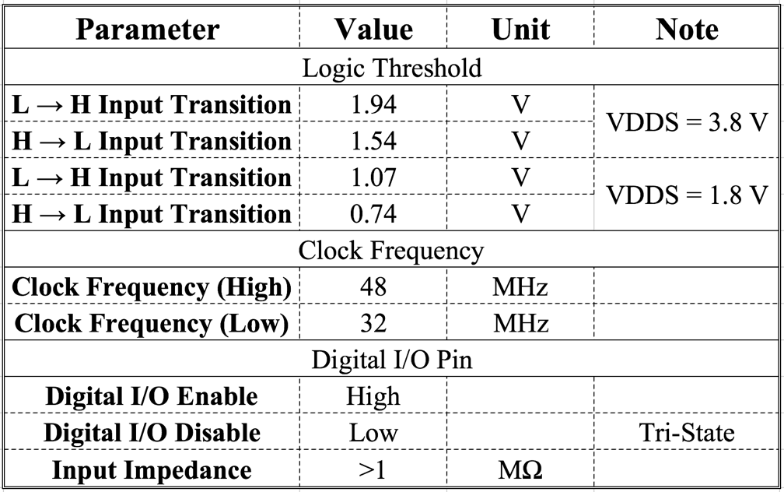

The datasheet gives two values for low to high transition voltage. In our case, because the battery supply is up to 3V, the team believe the L to H transition will happen at around 1.07V to 1.94V when VDD=3V. This voltage is used as a logic threshold the time-based measurement, because the time ratio in the RC circuit requires the capacitor charge from 0 to the same logic threshold point, as discussed in the following section. Additional to the threshold voltage, the microcontroller is able to provide up to 48MHz clock signal. Although it requires more power, the advantage of using higher frequency outstrips the disadvantage of power dissipation. Equation 11 shows the dynamic power dissipation as a function of frequency and the power dissipation at 48kHz can be found in Table 3.2. Moreover, the team believed that the voltage across the capacitor which is the input signal into the digital pin does not overdrive the digital pin because the input impedance of this microcontroller is larger than 1MΩ.

## Preliminary Design

To apply the time-based measurement technic, the team constructed the circuit into RC configuration, depicted in Figure 3.1. Every switch in the circuit will be responsible to connect the corresponding resistor to construct different RC circuits. As we discuss in section 2.4, every RC combination gives rise to different rise time. And the time periods for each RC combination are calculated with respect to a certain Vc, the voltage across the capacitor. In the other words, the team needed to tell the circuit a time to turn on the charging switch to charge up the capacitor and to turn on the discharging switch to discharge the capacitor. Thus, a threshold voltage is wanted. According to Table 3.1, when VDDS is 3.8V, the threshold voltage where digital input transits from low to high is 1.94V. Therefore, the team was able to utilize this transition in the microcontroller as the logic threshold for toggling the switches.

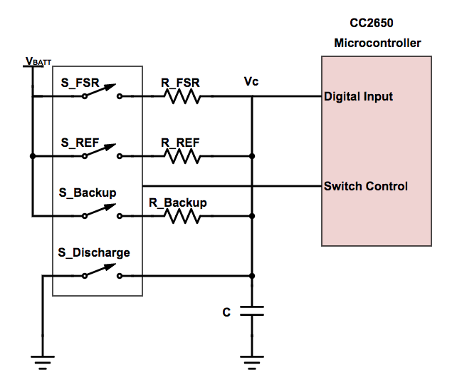

Figure 3.1: Preliminary Design

The corresponding expected output behavior is shown in Figure 3.2. By connecting the switch S_FSR, RFSR is connected to the capacitor, leading to a t1 rise time to reach to VLTH. Similarly, a RREF and C combination contributes to a t2 rise time to reach to VLTH. After Vc reaches the logic threshold VLTH, the SFSR or SREF switch will be disconnected and in the same time, the discharge switch will be connected to release the charge in the capacitor and prepare for the next cycle. The backup resistor RBACKUP will be used in parallel with RFSR when RFSR is too large to reduce the charging time due to the large RFSR.

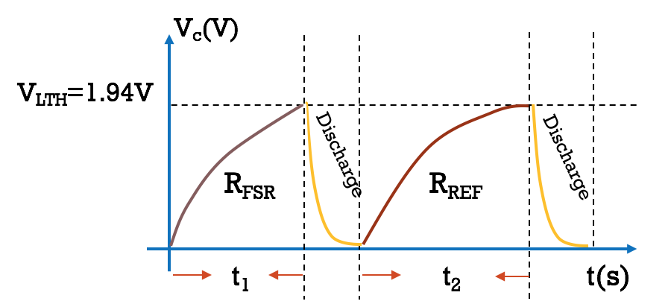

Figure 3.2: Expected Output Behavior

Mathematical analysis has been done using Equation 3. The rise time t1 and t2 are determined using

|  |  |
| --- | --- |
| $$Vc\left(t\right)=V_{BATT}-\left(V_{BATT}-0\right)e^{\frac{-t}{R*C}}$$ | (25) |
| $$V_{LTH}=V_{BATT}-V_{BATT}*e^{\frac{-t}{R*C}}$$ | (26) |
| $$t1=-\ln\left(1-\frac{V_{LTH}}{V_{BATT}}\right)*R_{FSR}*C$$ | (27) |
| $$t2=-\ln\left(1-\frac{V_{LTH}}{V_{BATT}}\right)*R_{REF}*C$$ | (28) |

Dividing (14) to (15) gives

|  |  |
| --- | --- |
| $$\frac{t_{2}}{t_{1}}=\frac{R_{REF}}{R_{FSR}}$$ | (29) |

The bright side of Equation 16 is that it indicated the resistor value only depends on the time ratio between t1 and t2. The measurement is totally not related to the battery voltage and does not require a reference voltage. This is corresponding to the project goal that discuss in section 1.3.

## Error Analysis

Almost every time we present a measurement, the experimental result will not be an exact number. The result is more likely to be a range of number associated with the measurement. This range is described by uncertainty or error. Any error presented in the time ratio will result in an inaccurate resistance measurement. The team’s next task is to analyze the time ratio error, according to the Equation 16, due to the various kinds of noise. To find the error, the original equation always need to be manipulate in

|  |  |
| --- | --- |
| $$Measured Data=Ideal Value*(1±Error)$$ | (30) |

### Mathematical Computation

In our case, the error analysis is defined using

|  |  |
| --- | --- |
| $$\frac{t_{1_measured}}{t_{2_measured}}=\frac{t_{1}±∆t_{1}}{t_{2}±∆t_{2}}$$ | (31) |

where t1_measure and t2_measured represent the experimental results that are gotten from the microcontroller. t1 and t2 are the ideal rise times from RFSRC and RREFC combination respectively. Δt1 and Δt2 are the time error due to various of uncertainty, as depicted in Figure 3.3.

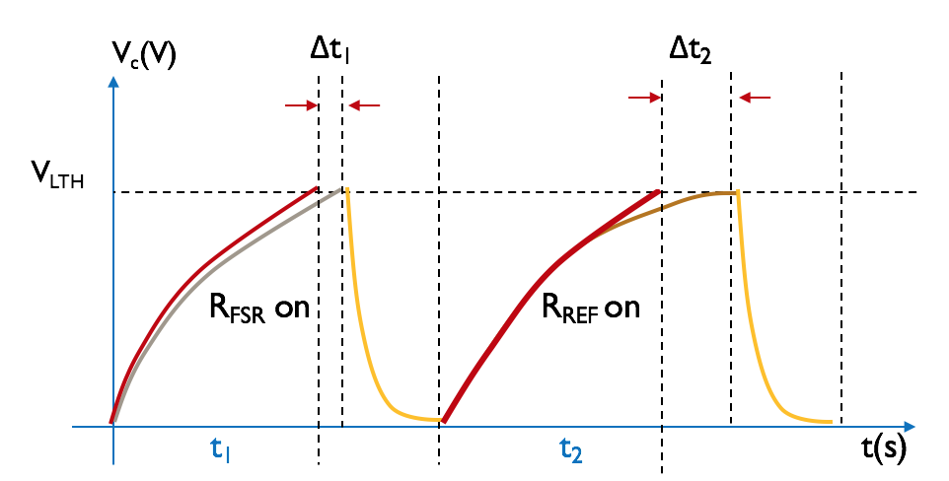

Figure 3.3: RC Charge and Discharge Diagram with Error

Factoring out t1/t2 from Equation 18 gives

|  |  |
| --- | --- |
| $$\frac{t_{1}}{t_{2}}*(\frac{1±{∆t_{1}}/{t_{1}}}{1±{∆t_{2}}/{t_{2}}})$$ | (32) |

According to the linear and quadratic approximations,

|  |  |
| --- | --- |
| $$\frac{1}{1+x }≈1-x for x≈0$$ | (33) |

Rearranging (19) by using (20) in the form of (17) results in

|  |  |
| --- | --- |
| $$\frac{t_{1}}{t_{2}}*(1+(\frac{∆t_{1}}{t_{1}}-\frac{∆t_{2}}{t_{2}}))$$ | (34) |

In the worst-case scenario, the maximum factional error (21) will be

|  |  |
| --- | --- |
| $$Worst Case Error=\frac{∆t}{t_{1}}+\frac{∆t}{t_{2}}$$ | (35) |

where Δt is the maximum time error for every rise time.

The final term is noted as the worst-case error expression:

|  |  |
| --- | --- |
| $$Maximum Error=\frac{∆t}{C}*(\frac{1}{R_{FSR}}+\frac{1}{R_{REF}})$$ | (36) |

To derive the minimum error from (23), the team used the following parameters:

* RRSR = 10kΩ
* C = 640nF
* RFSR: from 1kΩ to 100kΩ
* ∆t = 32µs (Note that section 3.5.2 will discuss on how to define ∆t)

Figure 3.4 is the plot generated by MATLAB using (23). From the Figure 3.4, the error increases to around ±5.5% at RFSR=1kΩ. The lowest error happens at RFSR=100kΩ and from RFSR=10kΩ to 100kΩ, the error is around 1%. Simulation result of (23) using Monte Carlo technique is presented in section 3.4.2 and the experiment result is presented in section 3.5.5.



Figure 3.4: Calculated Error with Respect to Force Sensitive Resistor from 1kΩ to 100kΩ.

### MATLAB Simulation

Monte Carlo technique is a broad class of computational algorithms that rely on repeated random sampling to obtain numerical results [ref]. This method is used to simulate the error of the time ratio due to the variation in time in MATLAB. A random Δt is produced and added to the expected rise time t1 or t2 (see Appendix 5.1 for the source code). The thought behind the MATLAB simulation is shown in Figure 3.5. The team first set the test condition that is the same as to the calculation condition:

* RRSR = 10kΩ
* C = 640nF
* RFSR: from 1kΩ to 100kΩ
* ∆t = 32µs (Note that section 3.5.2 will discuss on how to define ∆t)

Then the team calculated the ideal time ratio from given RFSR/RREF. And the real time ratio is calculated by adding random ∆t1 and ∆t2 into t1 and t2 respectively.

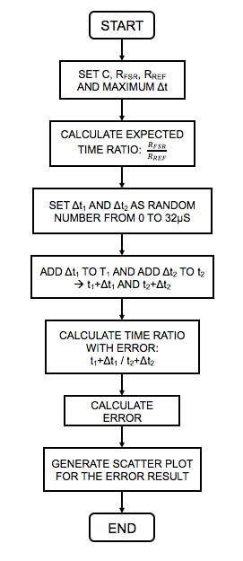

Figure 3.5: MATLAB Simulation Flowchart

The result that comes out from the MATLAB simulation is shown in Figure 3.6.



Figure 3.6: Simulated Error with Respect to Force Sensitive Resistor from 1kΩ to 100kΩ

### Conclusion

Combining Figure 3.4 and Figure 3.6 results in Figure 3.7. Having the simulated result sit between the maximum and minimum boundaries proves that the mathematical computation (23) is correct.



Figure 3.7: Simulated and Calculated Error with Respect to Force Sensitive Resistor from 1kΩ to 100kΩ

The team also calculated the dynamic power dissipate at f=32kHz and f=48MHz and the capacitor value needed for 1% error, 0.1% error and 0.01% error respectively, see Table 3.2 as a reference. The clock frequency can be found in Table 3.1. Additional to that, Power dissipation is determined by using (11) and capacitor values are determined by using (23).

Table 3.2: Summary of Power Dissipation and Capacitor Needed for 1%, 0.1% or 0.01% Error

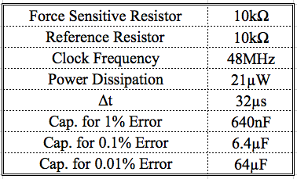

## Microcontroller Implementation

Next, the team processed to the next step bringing the preliminary design into the microcontroller. In order to combine different resistors with the capacitor, the design requires a switch to do the job. Instead of using an analog switch that requires adding another component into the design, the team utilized the high impedance feature in the microcontroller. To turn the “switch” off, we can simply turn the digital I/O pin into disable mode. Similarly, to connect the RFSR to VDD, the digital I/O, in our case, DIO24, can be set to “high”. The team used DIO26 to fast discharge the capacitor C to save more time for the measurement, because only the rise time will be involved in the calculation for the measurement. When RFSR is low, such as 1kΩ, C1 or C2 will be used to extend the measurement time to keep the measurement accurate. This will be discussed more section 3.5.5. To connect the capacitor to ground, the digital I/O pin can be set to low. Similarly, set the digital I/O pin to disable to switch the pin to high-impedance mode. The details about how the tristate inverter works are discussed in section 2.6.1. And the updated circuit diagram design is shown in Figure 3.8.

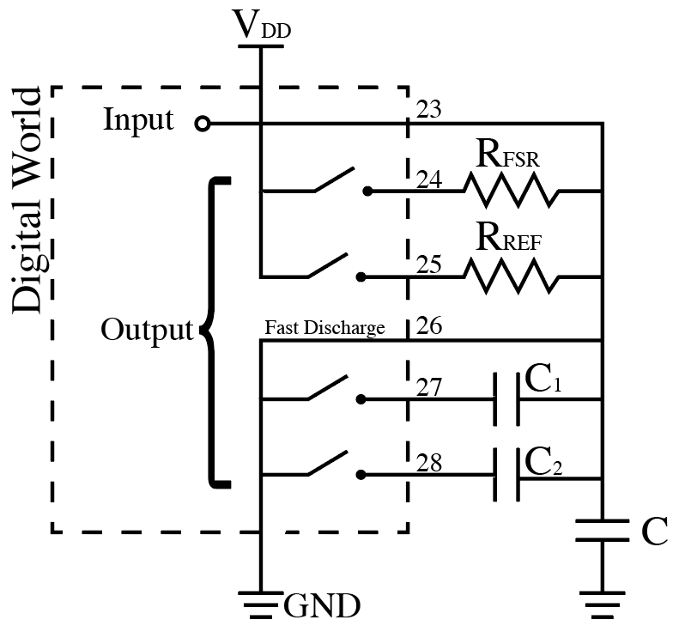

Figure 3.8: The Updated Circuit Diagram after Implementing in Microcontroller

### Programming Thoughts Behinds the Code

In terms of the microcontroller programming, the team first configured the 4 digital I/O pins, DIO23, DIO24, DIO25 and DIO26. The configuration table is shown in In terms of the output pins, DIO24 and DIO25 are configured into disable mode, but also configured into high, because when these pins are enabled, connecting to VDD is needed. To do that in the configuration, the team did not need to set the pin to logic high in the main function. Similarly, DIO26 is set to disable mode, and at the same time, it is set to logic low, because when DIO26 is enabled, it wants to provide a path to ground for discharging the capacitor.

Table 3.3. The DIO23 is set to enable initially because this input pin is to monitor the voltage across the capacitor and it does not need to be disabled. Setting the input DIO23 to positive edge trigger is recommended. At the very beginning, the team set the DIO23 to negative edge trigger mode, the measurement does not work. Later, the team figured out that because we want to trigger the circuit during the rise time, DIO23 need to be set into positive edge trigger mode.

In terms of the output pins, DIO24 and DIO25 are configured into disable mode, but also configured into high, because when these pins are enabled, connecting to VDD is needed. To do that in the configuration, the team did not need to set the pin to logic high in the main function. Similarly, DIO26 is set to disable mode, and at the same time, it is set to logic low, because when DIO26 is enabled, it wants to provide a path to ground for discharging the capacitor.

Table 3.3: Digital I/O Pins Configuration

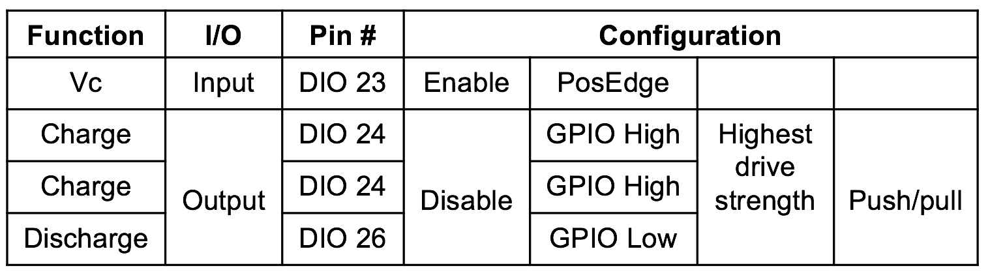

The thoughts behinds the code are shown as a flowchart in Figure 3.9. The main function handles the configuration and connection of initial charging for the capacitor. If there are any logic changes in DIO23, the interrupt will be triggered. Any time an interrupt is triggered, the microcontroller will record the end time, because this is when capacitor charging should be suspended and discharging will begin (see Figure 3.2). Next, the program will check if the changed input pin is DIO23 and if the change is from low to high, or in our case, if the capacitor is charging. If both conditions are satisfied, the program will process to disconnect the charging pin DIO24 or DIO25. In the same time, it connects the discharging pin DIO26 and releases the charge inside the capacitor. This is the time when ratio computation will happen. The time period between start and stop will be stored into a result array and the time ratio will be commutated after both time from RFSRC and RREFC combination is recorded. If there is only one time stored in the array, the program will continue to the next charging and discharging iteration. A delay is added after the computation, in order to provide enough time for the capacitor to discharge. For example, if RFSR or RREF is large, the discharge time will be longer. If the capacitor does not completely release its charge, the time ratio that the program calculated is inaccurate in the next iteration. After completely discharging the capacitor, next iteration will start by disconnecting the DIO26 and connecting the next charging pin. The next cycle will perform the same function as discussed.

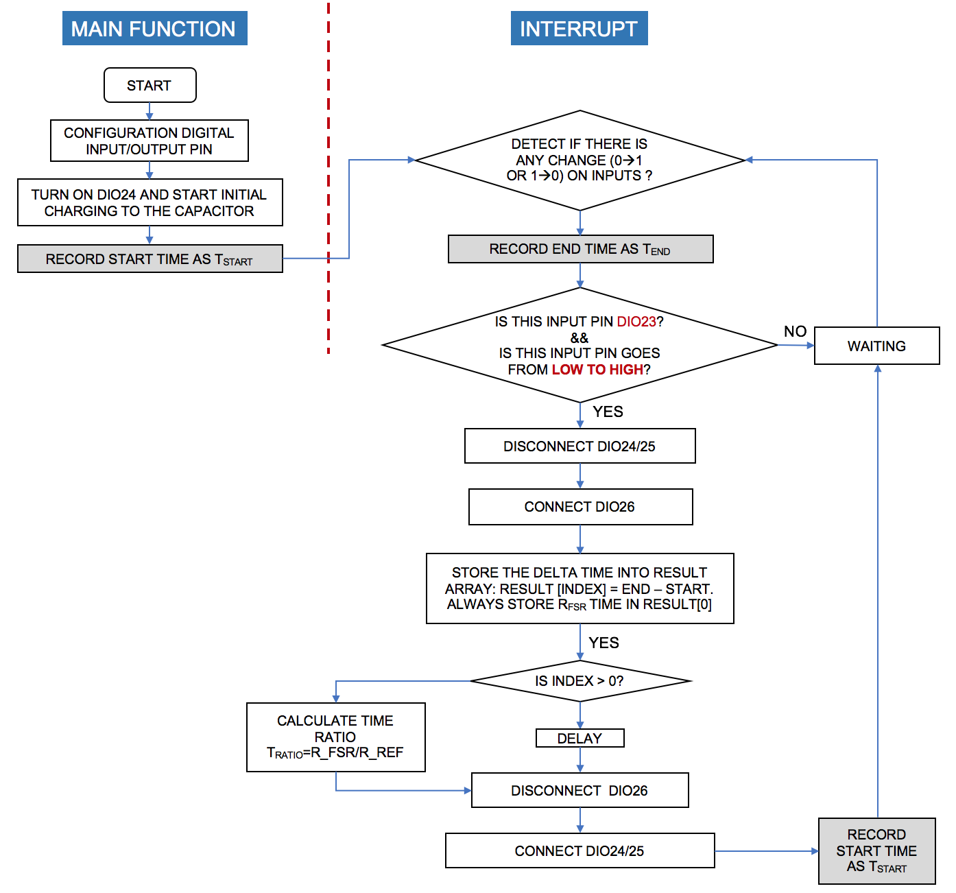

Figure 3.9: Microcontroller Flowchart

The clock that used to record the start time and stop time is called RTC (Real Time Clock). A detail discussion is presented in section 2.8. In our project, the team configured the RTC into the maximum frequency, shown in Figure 3.10, 48MHz to provide the highest resolution - 20.8 ns.

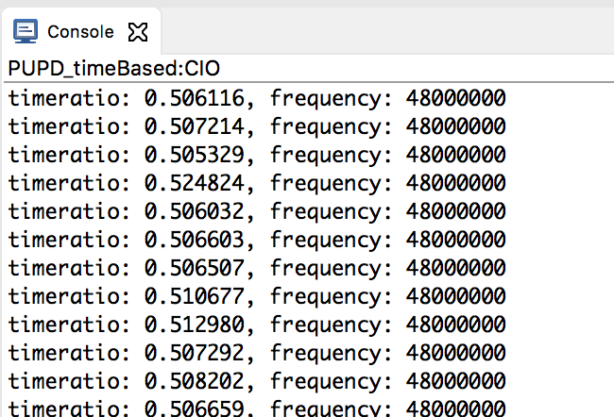

Figure 3.10: RTC Clock Frequency

# Experiment and Simulation

## Microcontroller Experiment

### Delta T Exploration – Triangle Wave Input Experiment

#### Purpose

This experiment is to find out the value of ∆t in the error equation (23) by forcing a triangle signal from function generator to DIO23 (see Figure 3.8).

#### Experiment Procedures

The team disconnected DIO23 (see Figure 3.8) to the RC network and force a triangle wave into DIO23 to trigger the interrupt. The rest of the component and configuration remained the same since the team wanted to change one variable at a time. The team swept the triangle wave frequency from 100Hz to 1000Hz and recorded 100 data of measurement time tmeas for every frequency, as shown in Figure 3.11. The MATLAB Code for plotting the data is attached in Appendix 5.3.

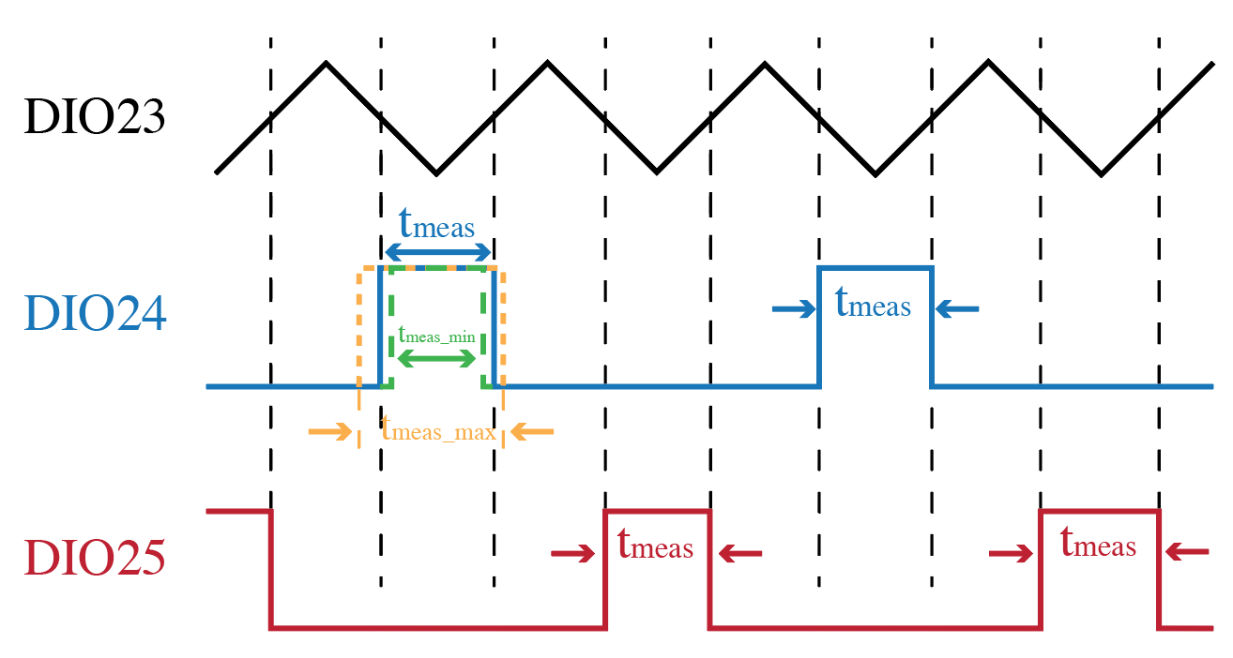

Figure 3.11: Triangle Wave Experiment Waveform Characteristic

If we take a closer look at DIO24 waveform, the team realized that, in every measurement, the time will vary. In the other words, the ideal measurement time is t1-t2, but experiment data shows that the measurement time can vary from tmax2-tmax1 to tmin2-tmin1, see Figure 3.12a. If the team aligned the left edge for the three different time, like Figure 3.12b, ∆t is then determined using

|  |  |
| --- | --- |
| $$∆t=tmax^{'}-tmin'$$ | (37) |

According to Figure 3.12a,

|  |  |
| --- | --- |
| $$tmax^{'}= tmax2+(t1-tmax1)$$ | (38) |
| $$tmin^{'}=tmin2-(tmin1-t1)$$ | (39) |

Subtracting (25) by (26),

|  |  |
| --- | --- |
| $$tmax^{'}- tmin^{'}=(tmax2-tmax1)-(tmin2-tmin1)$$ | (40) |

where tmax2-tmax1 is the maximum measurement time and tmin2-tmin1 is the minimum measurement time. Therefore, the ∆t in (23), can be determined by the difference between max and min measurement time.

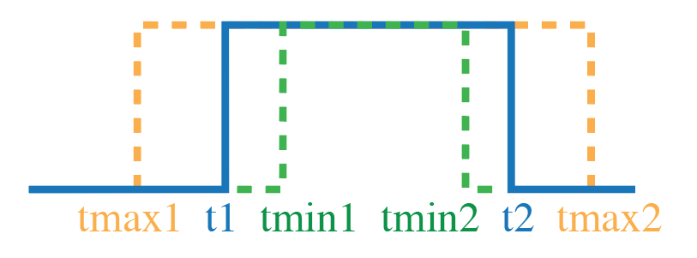

(a)

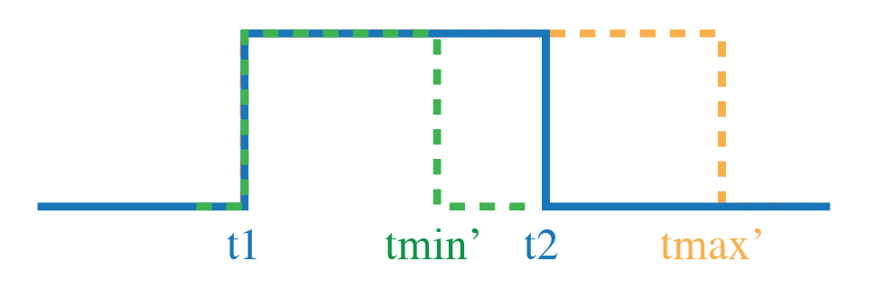

(b)

Figure 3.12 a&b: ∆t Computation

#### Experiment Results

Figure 3.13 presents the ∆t distribution among 100Hz frequency to 1kHz frequency. The typical ∆t, the team would say, is 32µs. The maximum error is happened when ∆t is maximum, in this case, 92µs. The variation typically happens at low frequency. In next term, the team will continue to deep into the ∆t experiment to find out if the variation happens randomly or if there is anything happen in that particular frequency range.



Figure 3.13: ∆t Experiment Result

### Frequency Sweep for Threshold Voltage Verification

#### Purpose

The team happened to see the threshold voltage changes when a higher frequency triangle wave is forced into the DIO23. This experiment is to explore the threshold behavior over a certain frequency range.

#### Experiment Procedures

The experiment is relatively straightforward. The detail procedures are listed below.

* Force a triangle wave into DIO23
  + Frequency: 100Hz to 1kHz
  + Amplitude: 3Vpp
  + Offset: 1.5V
* Use oscilloscope to measure the threshold voltage

#### Experiment Results

The team first observed that at low frequency, i.e. 10Hz to 100Hz, the interrupt trigger points are relatively constant. The trigger voltages seem to increase when the frequency, see Figure 3.14. Figure 3.15 presents the plot of interrupt trigger points for every frequency. The team can clearly see that after 100Hz, the trigger points start to presents a proportional relationship with frequency. The pheromone is unacceptable because the relationship between time ratio and resistor ratio as depicted (16), is based on the same trigger point as shown in Figure 3.2. If the logic threshold is frequency dependent, (16) cannot be applied for the measurement.

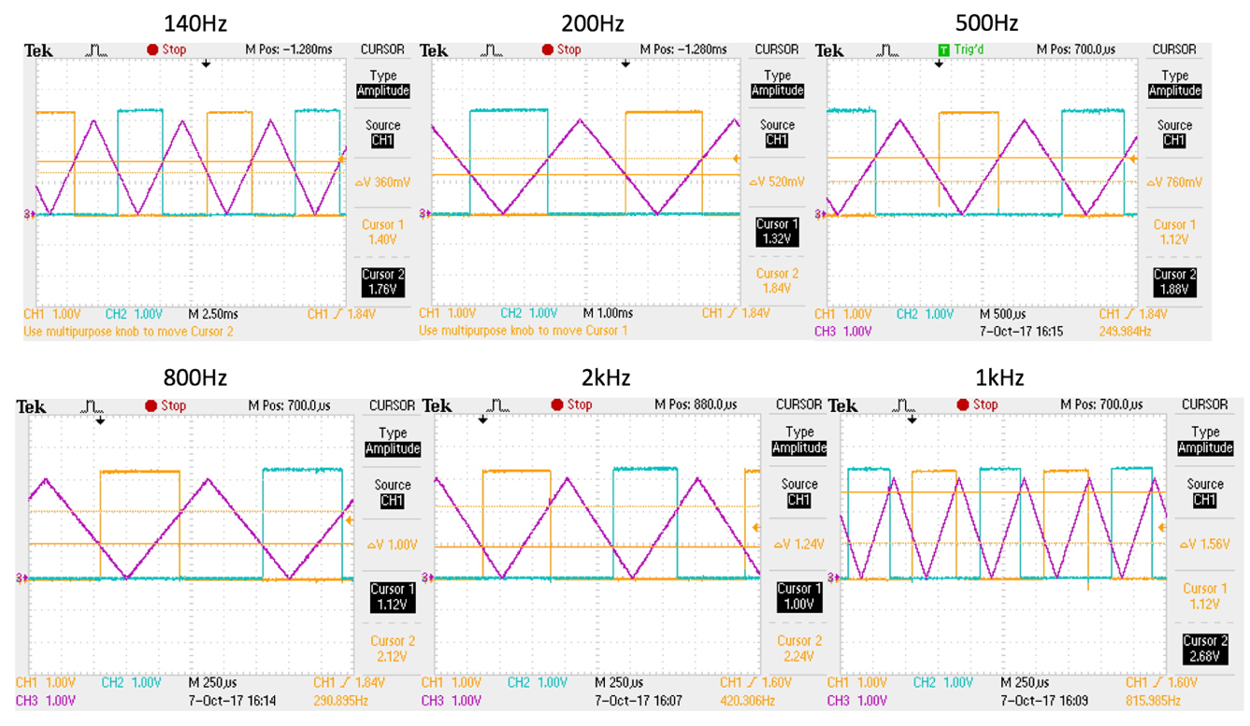

Figure 3.14: Oscilloscope Waveform for f=140Hz to f=1000Hz



Figure 3.15: Frequency Sweep for Interrupt Trigger Voltage Exploration

When the team pushed the frequency even higher to 1.5kHz and 2kHz, we can see, in Figure 3.16a&b, an even worse behavior. At some points, the channel 1 signal is trigger at the right place, but sometimes it doesn't. Moreover, the trigger point at the certain frequency, say 1.5kHz, changes over the time. for example, at one interrupt, the channel 1 signal trigger at 2.9V, but at another interrupt, the signal triggers at around 2.5V. The possible reason for this phenomenon to happen will be discussed in the conclusion part in this section.

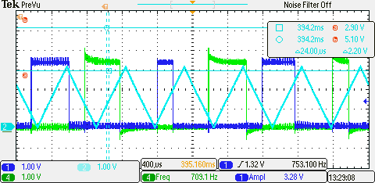

(a)

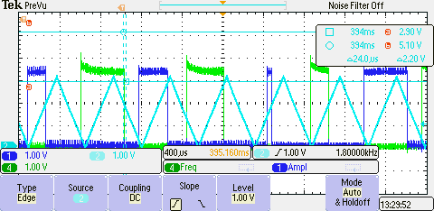

(b)

Figure 3.16 a&b: Oscilloscope Waveform at (a)1.5kHz and (b)2kHz

#### Discussion and Conclusion

Section 2.6.2 explains that the switching voltage does not have any relationship between frequency. According to the waveforms at 1.5kHz and 2kHz, the team believed that the switching points are not the factors that cause the shifted interrupt response, since at a certain interrupt, the signal does switch at the right switching point. Next, the team focused on time delay that can possibly explain the frequency dependent behavior. To explore the delay problem, the team first drew the circuit model in the Multisim, shown in Figure 3.17, giving Vin = 3V and V1=VDD=3V. By attaching a small parasitic model at the output of the circuit, the team did see a time delay at the output, as shown in Figure 3.18.

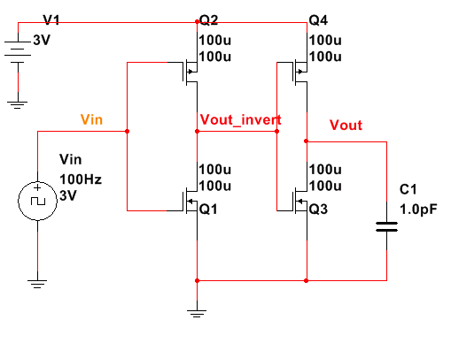

Figure 3.17: CMOS Circuit Model for Prorogation Delay

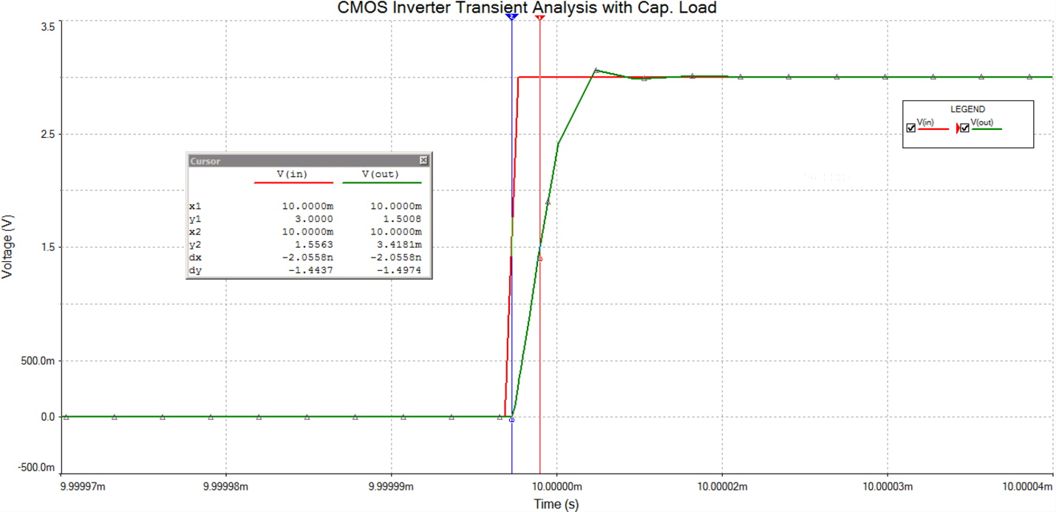

Figure 3.18: Low to High Propagation Delay Due To The Paracitic Capacitor

At first, the propagation delay due to the parasitic capacitor associated with the inverter seems to cause a problem. However, according to CMOS Circuit Design, Layout, and Simulation, the intrinsic propagation delays of the inverter are

|  |  |
| --- | --- |
| $$t_{PLH}=0.7*R_{p2}*C_{out}$$ | (41) |

Therefore, the propagation delay is also not related to the frequency at all.

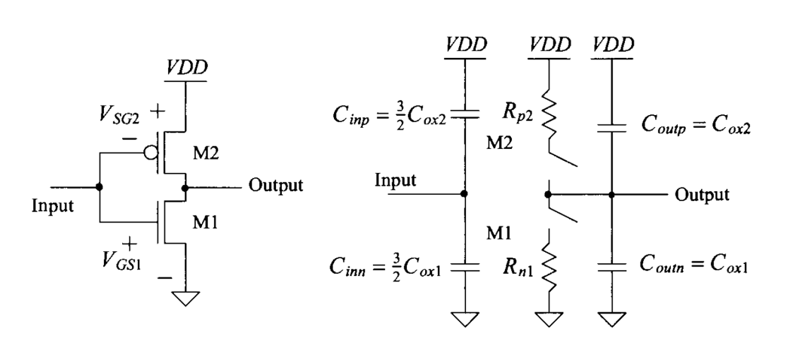

Figure 3.19: The CMOS Inverter Switching Characteristic using the Digital Model

Another possible explanation for the frequency dependent problem is clock signal in the MCU. In the digital world, clock signal provides timing for the logic switching. The clock is basically a particular type of signal that oscillates between a high and a low state and is utilized like a metronome to coordinate actions of digital circuits (Clock signal 2017). In our case, the MCU requires a reference to time for synchronization, command execution and data transfer. And every interrupt happens at the positive edge of the clock signal (In the MCU configuration, the team set the input pin to be trigger at a positive edge). In this case, if the frequency is higher and the clock signal cannot catch the interrupt trigger point, interrupt response will shift accordingly, as shown in Figure 3.20.

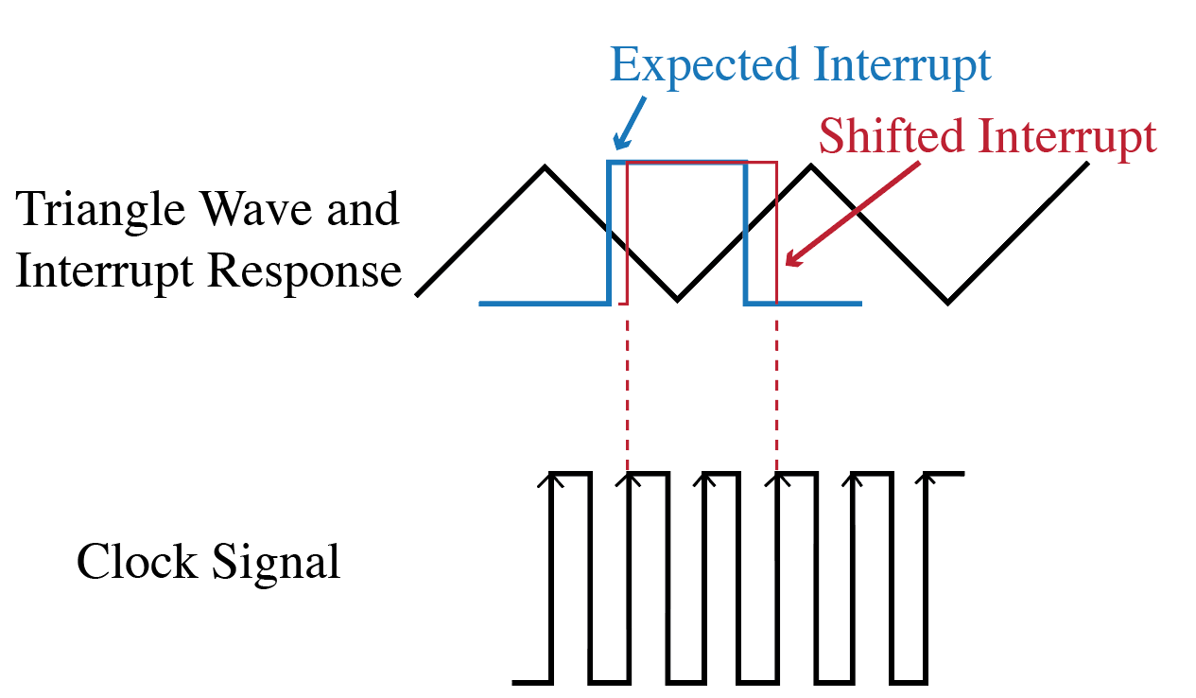

Figure 3.20: Clock Signal and Interrupt Response

To sum up, the problem presented in this experiment is caused by the mismatch at the higher frequency. Therefore, although it looks like the switching voltage has changed over the frequency, what happens in the MCU is that when the frequency is higher, the clock signal does not catch the trigger point at the positive edge and the interrupt signals have been delayed to next few clock edges.

### Capacitor vs Error Experiment

#### Purpose

The team observed that the accuracy of the measurement is related to the capacitor values. And the capacitor value has a direct relationship to the charging time. Thus, this experiment is conducted for the analysis of error and capacitor relationship.

#### Experiment Procedures

The team conducted the experiment by sweeping the capacitor C from 2nF to 10μF, see Figure 3.8. The other components in the circuit remain the same. A detail experiment condition is listed below.

* 48MHz Real Time Clock
* RFSR=10kΩ (Actual RFSR = 9.87 kΩ)
* RREF=10kΩ (Actual RREF = 9.97 kΩ)
* C: from 2nF to 10μF

The time ratio data corresponding to each capacitor is calculated by the microcontroller CC2650 and printed by the MCU in Code Composer Studio console window. Table 3.4 shows the data sample that was collected by the team. Additionally, the error in Table 3.4 is calculated according to (29).

|  |  |
| --- | --- |
| $$Error=\frac{{\left(Measured Time Ratio*R_{REF}\right)-R}_{FSR}}{R_{FSR}}*100\%$$ | (42) |

Table 3.4: Error vs Capacitor Data Example

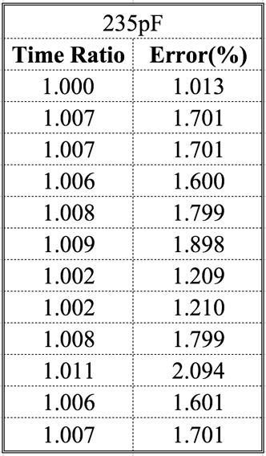

The team also wrote a MATLAB code for the simulation to compare with the experiment results, (see Appendix 5.3). Equation 23, also shown below, is used in the simulation to compute the ideal error where ∆t is the typical value 32µs. The team took 5000 data points in MATLAB and plot it in log-log scale in order to see the small difference between simulation results and experiment results.

|  |
| --- |
| $$Maximum Error=\frac{∆t}{C}*(\frac{1}{R_{FSR}}+\frac{1}{R_{REF}})$$ |

#### Experiment and Simulation Results

Figure 3.21 shows the experiment results and the simulation results. In the simulation, the error continues to decrease when the team pushed the capacitor to 10μF. However, the experiment results show that at about 100nF, the error stops decreasing. Even the team pushed the capacitor into a higher value, the error is still around 0.1% to 1%. This phenomenon would help to explain the 3.5.5 experiment. In that experiment, when the team added more capacitor in parallel with each other, the error at 1k stays at 10%.



Figure 3.21: Experimental and Simulation Data: Error vs Capacitance

### Resistor RFSR vs Error and RFSR vs Measurement Time Experiments

#### Purpose

The purpose of this experiment is to investigate the relationship between the applied resistor and the error since the resistor value directly related to the applied pressure. Different capacitor values are used to see the improvement on measurement error when extra capacitors are added into the circuit. However, because adding more capacitor means the time to take measurement will also increase. This is the reason why another experiment – RFSR vs measurement time are present along with the error experiment.

#### Experiment Procedures

The error experiment is presented by the following test condition:

* RFSR: 1kΩ to 100kΩ
* RREF = 10kΩ
* C = 640nF (see Table 3.2)
* Extra capacitor = 2.25µF (1 to 4 extra capacitors are added one by one in the experiment)
* Error is calculated by Equation 29

The simulation shows the maximum error due to the 640nF capacitor where ∆t = 92µs, C=640nF, RREF=10kΩ and RFSR is swept from 1kΩ to 100kΩ. The MATLAB code can be found in Appendix 5.4.

The measurement time is taken by measuring the difference between start time and end time for every measurement in RFSRC combination.

#### Experiment and Simulation Results

It is fair to say that at about 8kΩ, the error starts to get larger. This can be related section 3.5.3, when resistor value is low, the frequency of input signal at DIO23 increases. When the frequency increase, the clock speed cannot catch up with the trigger points and therefore shows a decent amount of delay in the interrupt response. In this case, the interrupt trigger voltages for RFSR=1kΩ and RREF=10kΩ are not at the same level, which will lead to a large error, because our Equation 16 cannot be applied when threshold voltage is not the same for every RC combination.

As Figure 3.22 presents, without adding extra capacitor into the circuit, the experiment error starts to exceed the maximum error that simulation predicts at RFSR = 4kΩ. To reduce the error, the team added one extra capacitor in another digital I/O pin and in parallel with the original capacitor. By doing this, the error at RFSR=1kΩ decreases from 39% to 18%. However, when the team continued to add more capacitor in parallel with each other, the error at RFSR=1kΩ stop to decrease. This reminds us of the capacitor experiment in section 3.5.4. In that section, the team observed that in the simulation, the error will decrease when more capacitor is added into the circuit. However, in the experiment, the team realized that at C=1µF, the error stops decreasing and stays at around 0.5%. The capacitor in section 3.5.4 is conducted by using RFSR=10kΩ, but the behavior can be used to explain the error limit when more capacitor is added into the circuit.

The tradeoff the team needed to consider is the measurement time. By adding more capacitor, the measurement time will increase because the measurement time is related to the time constant $τ.$

|  |  |
| --- | --- |
| $$τ=R*C$$ | (43) |

As we can see in the bottom plot in Figure 3.22, even though the error does not decrease when 3 and 4 2.25µF capacitors are added into the circuit, the time at RFSR increases from 50ms to 60ms. In this case, the team needed to consider the balance between measurement time and accepted maximum error to find out the if the extra capacitor switch is necessary and what is the optimized value for the extra capacitor.



Figure 3.22: Experiment and Simulation for Error and Measurement Time over Different Resistors RFSR

## Error Simulation & System Implementation

### Purpose

Previously, a worst-case error had been developed. This experiment is to verify the accuracy of the error analysis. If the experimental error data is within the maximum predicted error boundary, the team will be more confident about the error simulation and analysis.

### Experiment Procedures

The resistors the team used are shown below,

* 1kΩ
* 3kΩ
* 8kΩ
* 10kΩ
* 30kΩ
* 80kΩ
* 100kΩ

Result were plotted in log-log scale using the MATLAB. The error is calculated in the Code Composer Studio like the code shown below.

printf("Error = %f\n", (((time_ratio*Rref)-res)/res)*100);

There are three configurations in this experiment,

1. Rref = 10kΩ & C = C1
2. Rref = 10kΩ & C = C1 + C2
3. Rref = 1kΩ & C = C1 + C2

### Experiment Results

Figure 3.23: Error Experiment ResultsFigure 3.23 shows the experiment results. It can be seen that in all the three scenarios, the experimental error is at all times less than the simulated error. The simulated error is the worst-case error for each scenario. The choice of C1 and C2 is based on the values shown in Table 3.5.

Table 3.5: Choice of C1, C2, RREF1, RREF2

|  |  |  |
| --- | --- | --- |
| Component | Value | Unit |
| C1 | 640 | nF |
| C2 | 2.25 | µF |
| Rref1 | 10 | kΩ |
| R­ref2 | 1 | kΩ |



Figure 3.23: Error Experiment Results

Figure 3.24 shows us the experimental error of all the three scenarios together. The lower plot of Figure 3.24 shows the charging time for the three scenarios as RFSR varies from 1kΩ to 100kΩ. We can see from the results that we do need to have a reconfigurable system where the system needs to change the value of capacitor and RREF. The solid line on Figure 3.24 shows how the system needs to be reconfigured in order to ensure the error and charging time are both within acceptable limits. As RFSR > 10kΩ, we can use RREF1 and C1. As RFSR falls below 10kΩ, C2 is added in parallel to C1. In this situation, we reduce the measurement error but increase the charging time, which is within acceptable limits. When RFSR < 2.5kΩ, we switch to RREF2, which reduces measurement error and charging time as the value of RFSR keep decreasing. The reconfigurable system shown **in** Figure 3.8 is tested as RFSR is varied from 1kΩ to 100kΩ. The implemented system is represented by the squares in Figure 3.24. We can see that the implemented system follows the pattern of the proposed system.

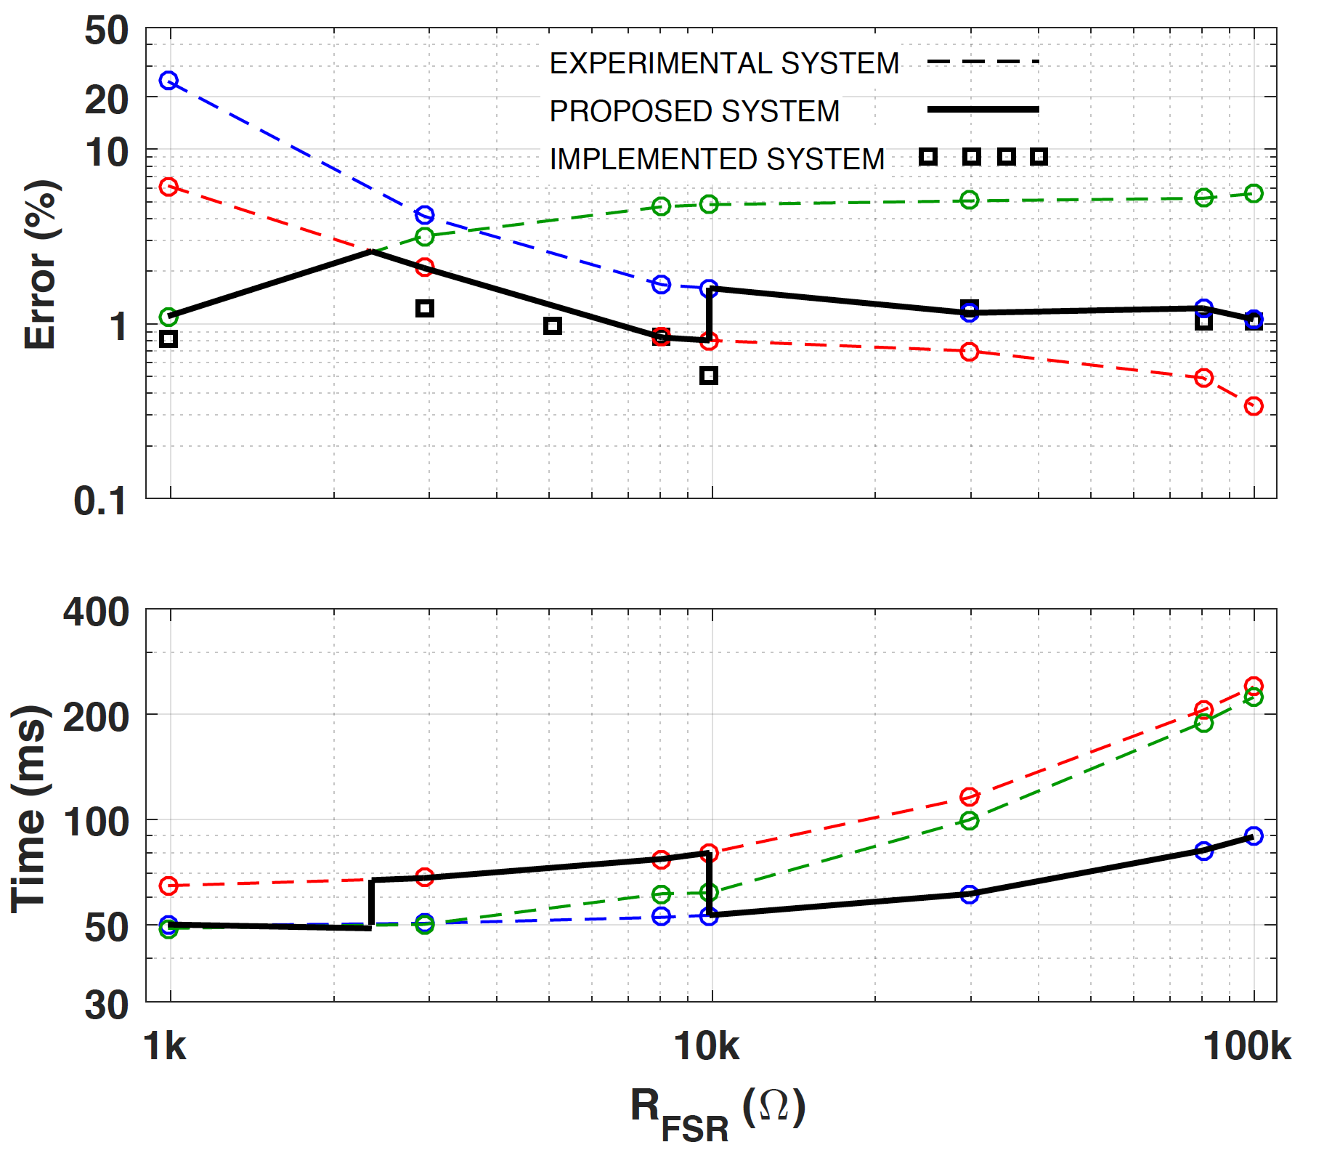

Figure 3.24: System Implementation Experiment Results

Figure 3.25 shows the scope image of the implemented system. We can see that the capacitor charges through either RFSR or RREF, depending on which switch is enabled. And it gets discharged almost instantly when the discharge switch is enabled. The waveforms look similar to the anticipated waveform shown in Figure 3.2.

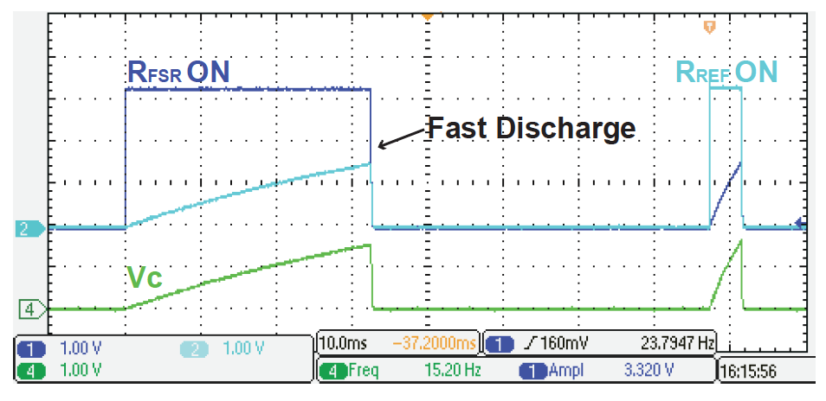

Figure 3.25: Scope Picture of System Implementation

## Further System Implementation

### Purpose

A further implementation experiment has been conducted. The purpose of this experiment is to achieve controlling the switch automatically.

### Experiment Procedures

Initially, the team is trying to use the time as threshold to control the switch. The flowcharts are shown in Figure 3.26 and Figure 3.27. When time is larger than B, C1 is turned on and when time is smaller than A, both C1 and C2 are turned on to give more charging time to the system. A switching window A-B is created because when C2 is turn on, the charging time is increase. Therefore, the team created a “don't care” stage for this situation. However, the team found that using time as a threshold is not ideal and time can be easily connected to the resistance.

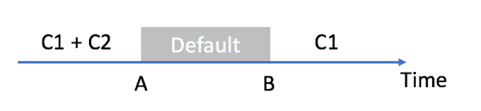

Figure 3.26: Implementation Flowchart

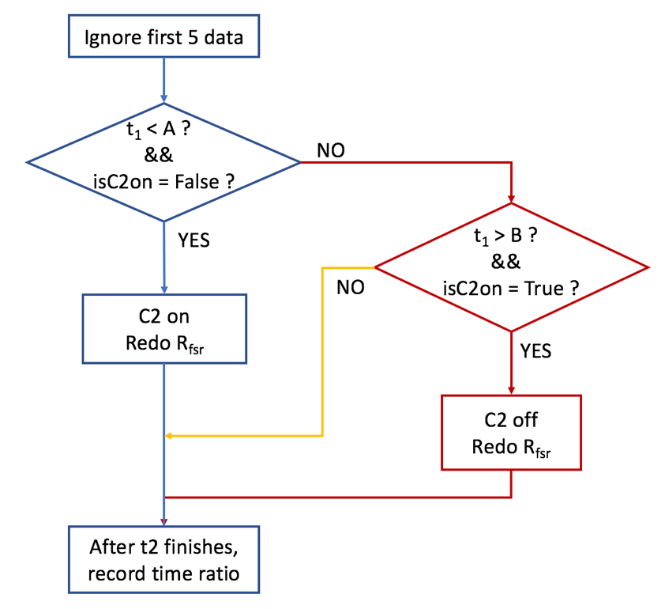

Figure 3.27: Implementation Flowchart

Therefore, the final procedure is to determine the RFSR value first. If RFSR is larger than 10kΩ, C1 is turned on. If RFSR is smaller than 8kΩ, C1 and C2 are turned on. If RFSR is larger than 8kΩ, RREF1 is used and similarly, if RFSR is smaller than 1.5kΩ, RREF2 is used. Figure 3.28 shows the concept of final implementation.

~~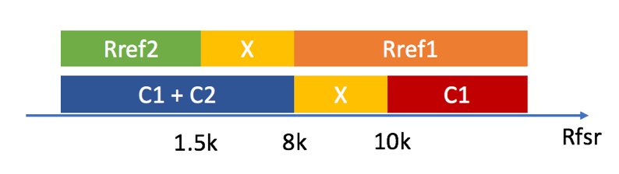~~

Figure 3.28: Updated Implementation Flowchart

To further decrease the measurement error, the team used a third capacitor C3, 2.25µF, when the RFSR reaches 2kΩ or lower. Table 3.6 indicates the procedure of the whole experiment.

Table 3.6: Experiment Procedures

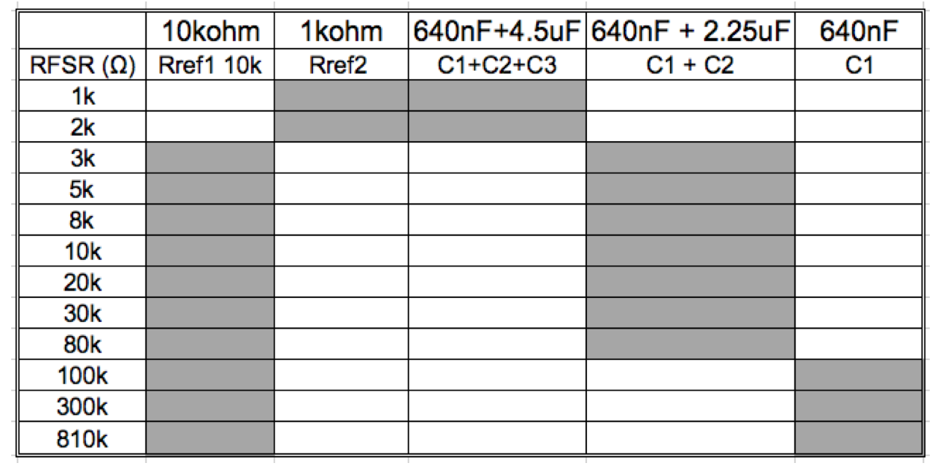

### Experiment Results

Figure 3.29 shows the experiment error results for the further implementation, as well as the measurement time along with different pair of resistor and capacitor. As the RFSR value decreases, the team switches to a larger capacitor to decrease the measurement error. However, there is a measurement time trade off, because using a bigger capacitor indicates a larger measurement time. The solid line shows the maximum error that the simulation predicts and the scatter plot indicates the measurement system error.

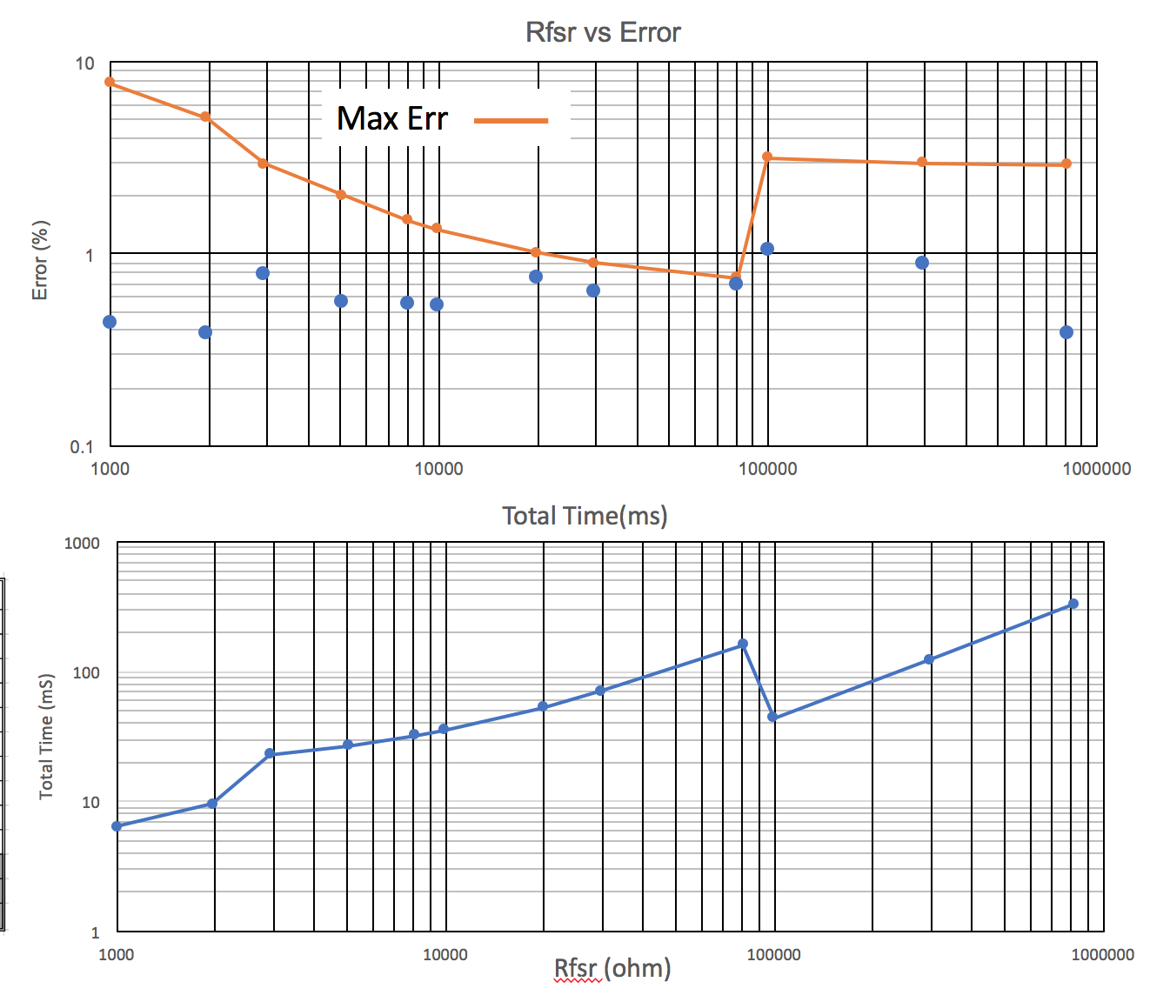

Figure 3.29: Experiment Results for System Implementation

## Creep Behavior

### Purpose

The experiment investigates the non-idealities of creep behavior in polymer composites.

### Experiment Procedures

According to the equation XX, the team consider the constant as parameter A, B and n, since the team cannot determine the actual material inside the FSR sensor. The creep model is showed in Equation 36.

|  |  |
| --- | --- |
| $$R=R0*\left[1-At^{n}\right]e^{-B*t^{n}}$$ | (44) |

The team used the MATLAB to create a best fit curve the fit in the creep data. The data are generated by Ben during the 2017 summer. The weight he used is 133g, 174g, 215g and 255g. Since the data are in unit of gram, the team convert the unit to stress’s unit according to the Equation 37. And the results are shown in Table 3.7.

|  |  |
| --- | --- |
| 𝜎= 𝐹/𝐴=(𝑚∗𝑔)/𝐴 | (45) |

Table 3.7: Weight to Stress Table

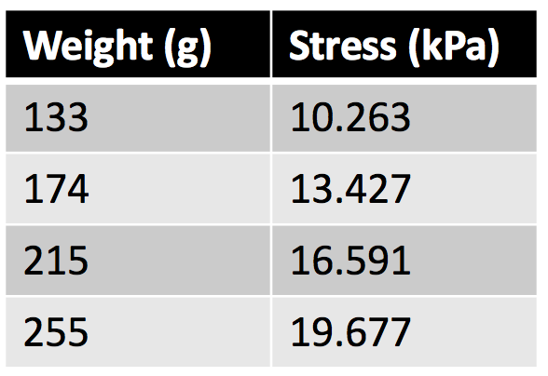

### Experiment Results

The best fit curve, R/R0 vs time, is shown in Figure 3.30 and the predicted parameter, a, b, n are listed in Table 3.8. The original model determines the R/R0 time dependence equation, but in our experiment, the team cannot determine R0 since the team was not sure about the initial resistance value. In this case, the team used the data in Table B to determine the a, b and n value and use the best fitting curve function to find the real value of R0.

Table 3.8: A, B and N Parameter Prediction

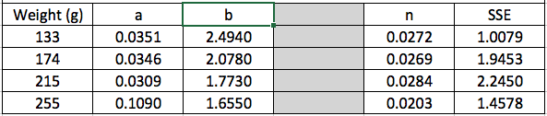



Figure 3.30: R/R0 vs t Best Fit Curve Results

The experiment result for R vs time is shown in Figure 3.31. the following value is chosen for a, b and n,

* A = 0.04
* B = 2.1
* N = 0.02358

However, the team still concerned about R0 value in Table 2.1 because R0 supposed to decrease as the weight increase. A further experiment will be conducted in C term.

Table 3.9: R0 Prediction

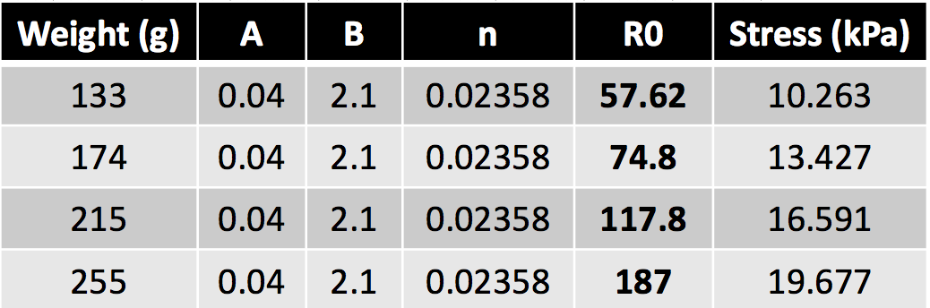



Figure 3.31: R vs Time MATLAB Results

# Conclusion

As a conclusion, time-based measurement did present a battery independency characteristic. However, a more further improvement needs to be considered because at RFSR=1kΩ to 10kΩ, the error is up to 10%, which is not an ideal measurement case for the pressure ulcers prevention system. The team saw the error starts to ramp up at 10kΩ and suspect that suspect that this behavior is related to the reference resistor RREF=10kΩ that the team used in the time-based measurement circuit. In this case, a further experiment may be conducted in next term. Another experiment the team will achieve in next term is to implement the system with the pressure sensor and investigate the accuracy in terms of the pressure measurement, since eventually this RC time-based measurement will be included into the pressure ulcers prevention system.

In terms of the overall lesson learned, before the team’s senior year, the team only used Microsoft Excel to plot the data and did not understand why people use MATLAB to complete a simple task that Microsoft Excel can also complete. However, after the team’s senior A term, the team was impressed by MATLAB since it includes myriad functions that Microsoft Excel cannot achieve. The team also gained a decent amount of microcontroller coding skill and had a chance to apply what the team learned at school to a project. Overall, the A term project experience is valuable for the team and the team will continue to contribute for the project next term.

# References

5 tips for preventing bed sores in bedridden patients. (2015, -05-27T09:00:03-05:00). Retrieved from <https://www.advancedtissue.com/5-tips-for-preventing-bed-sores-in-bedridden-patients/>

Agdeppa, A., Hussasin, S. A., Kim, H., & Loehle, V. (2017). *Pressure ulcer prevention system.* ().

Baker, R. J. (2010). *CMOS circuit design, layout, and simulation* (3. ed. ed.). Hoboken, NJ: Wiley-IEEE Press.

Bhattacharya, S., & Mishra, R. K. (2015). Pressure ulcers: Current understanding and newer modalities of treatment.*Indian Journal of Plastic Surgery : Official Publication of the Association of Plastic Surgeons of India, 48*(1), 4-16. doi:10.4103/0970-0358.155260

*Clock signal* (2017). Retrieved from <https://en.wikipedia.org/w/index.php?title=Clock_signal&oldid=800423525>

Difference between system clock and real time clock. (2016, -11-12). Retrieved from <https://anydifferencebetween.com/difference-between-system-clock-and-real-time-clock/>

Eckman, K. L. (1989). The prevalence of dermal ulcers among persons in the U.S. who have died.*Decubitus, 2*(2), 36-40.

Edlich, R., Winters, K. L., Woodard, C. R., Buschbacher, R. M., Iii, W. B. L., Gebhart, J. H., & Ma, E. K. (2004). Pressure ulcer prevention.*Journal of Long-Term Effects of Medical Implants, 14*(4) doi:10.1615/JLongTermEffMedImplants.v14.i4.20

Harvard Health. (2014). Bedsores (decubitus ulcers). Retrieved from <https://www.health.harvard.edu/diseases-and-conditions/bedsores-decubitus-ulcers->

Hoffman, M. (2014). Achilles tendon (human anatomy): Picture, definition, injuries, pain, and more. Retrieved from <https://www.webmd.com/fitness-exercise/picture-of-the-achilles-tendon>

McNeill, J., Sen, D., Mendelson, Y., Crivello, M., Mazumder, S., Agdeppa, A., . . . Dunn, R.*Wearable wireless sensor patch for continuous monitoring of skin temperature pressure, and relative humidity  
.* ().IEEE International Symposium on Circuits and Systems.

McNeill, J., Crivello, M., Sen, D., & Mendelson, Y. (2016). Modeling of force sensor nonlinearity for  
time-domain-based pressure measurement in  
biomedical sensors.*Northeast Bioengineering Conference (NEBEC),*, 1-2.

*Monte carlo method* (2017). Retrieved from <https://en.wikipedia.org/w/index.php?title=Monte_Carlo_method&oldid=801308029>

RC charging circuit tutorial & RC time constant. (2013a, -08-27T07:01:21Z). Retrieved from <http://www.electronics-tutorials.ws/rc/rc_1.html>

RC charging circuit tutorial & RC time constant. (2013b, -08-27T07:01:21Z). Retrieved from <http://www.electronics-tutorials.ws/rc/rc_1.html>

*Real-time clock* (2017). Retrieved from <https://en.wikipedia.org/w/index.php?title=Real-time_clock&oldid=799512149>

Real-time clock (RTC). (2005). Retrieved from <http://whatis.techtarget.com/definition/real-time-clock-RTC>

# Appendices

## MATLAB Code of Error Analysis Simulation

%%%%%%%%%%%%%%%%%%%%%%%%%%%%%%%%%%%%%%%%%%%%%%%%%%%%%%

% Week 4 2017/10/5

% Purpose: Error analysis simulation

%          and comparison between mathmatical computation

%

%   Copyright (c) 2017 by Shanshan Xie

%   for Pressure Ulcer Prevention project

%%%%%%%%%%%%%%%%%%%%%%%%%%%%%%%%%%%%%%%%%%%%%%%%%%%%%%

%Set Test Condition

C = 0.64e-6;

Rref = 10000;

Rfsr = 1e3:100:100e3;

delta_t = 32e-6;

Ideal_time_ratio = Rfsr./Rref;

t1 = C*Rfsr;

t2 = C*Rref*ones(1,length(t1));

%random number generation

rand_delta_t1 = delta_t*rand(1,length(t1));

rand_delta_t2 = delta_t*rand(1,length(t1));

t2_wError = t2 + rand_delta_t2;

t1_wError = t1 + rand_delta_t1;

timeRatio_wError = t1_wError./t2_wError;

% +/- Error

Error_sim1 = ((timeRatio_wError./Ideal_time_ratio)-1)*100;

Error_sim2 = (1-(timeRatio_wError./Ideal_time_ratio))*100;

%Computation Result

error = (delta_t./C)*(1./Rfsr+1/Rref)*100;

semilogx(Rfsr, error, 'LineWidth',2);

hold on

semilogx(Rfsr, -error, 'LineWidth',2);

%Simulation Result

% hold on

scatter(Ideal_time_ratio*Rref, Error_sim1, 'b');

hold on

scatter(Ideal_time_ratio*Rref,Error_sim2, 'r');

grid on

grid minor

xticks([1000 10000 100000])

xticklabels({'1k', '10k', '100k'})

xlabel('Force Sensitive Resistor R_{FSR} (\Omega)','FontSize', 20)

% title('Force Sensitive Resistor vs Error','FontSize', 20)

ylabel('Error (%)','FontSize', 20)

lgd = legend('Simulation1','Simulation2','Calculation1','Calculation2');

lgd.FontSize = 16;

## MATLAB Code of Delta Time Experiment

%%%%%%%%%%%%%%%%%%%%%%%%%%%%%%%%%%%%%%%%%%%%%%%%%%%%%%

% Week 4 2017/10/5

% Purpose:  This experiment is to find out the value of ?t

%           in the error equation (23) by forcing a triangle

%           signal from function generator to DIO23.

%

%   Copyright (c) 2017 by Shanshan Xie

%   for Pressure Ulcer Prevention project

%%%%%%%%%%%%%%%%%%%%%%%%%%%%%%%%%%%%%%%%%%%%%%%%%%%%%%

%add the data from excel

dataset = xlsread('week6_added_cap_experiment.xlsx', 'deltaT', 'A2:B32');

frequency = dataset(:,1);

deltaT = dataset(:,2);

scatter(frequency,deltaT,'b','linewidth',2);

grid on

grid minor

xlabel('Applied Frequency (Hz)','FontSize', 20);

ylabel('Maxtime-Mintime (us)','FontSize', 20);

title('Time Delta Measurement','FontSize', 24);

## MATLAB Code of Capacitor vs Error Experiment

%%%%%%%%%%%%%%%%%%%%%%%%%%%%%%%%%%%%%%%%%%%%%%%%%%%%%%

% Week 5 2017/10/13

% Purpose:  Experiment of the accuracy of the measurement

%           is related to the capacitor values.

%

%   Copyright (c) 2017 by Shanshan Xie

%   for Pressure Ulcer Prevention project

%%%%%%%%%%%%%%%%%%%%%%%%%%%%%%%%%%%%%%%%%%%%%%%%%%%%%%

%get data from excel

dataset = xlsread('err_cap_res.xlsx', 'capacitor', 'A2:AN13');

c2 = dataset(1,1);

err1 = dataset(:,2);

mean2 = mean(err1);

% scatter(Rfsr_1k./1000, mean_1k,100);

c3 = dataset(1,3);

err2 = dataset(:,4);

mean3 = mean(err2);

% hold on

% scatter(Rfsr_2k./1000, mean_2k,100);

c5 = dataset(1,5);

err3 = dataset(:,6);

mean5 = mean(err3);

% hold on

% scatter(Rfsr_3k./1000, mean_3k,100);

c6 = dataset(1,7);

err6 = dataset(:,8);

mean6 = mean(err6);

% hold on

% scatter(Rfsr_7_5k./1000, mean_7_5k,100);

c7 = dataset(1,9);

err7 = dataset(:,10);

mean7 = mean(err7);

% hold on

% scatter(Rfsr_10k./1000, mean_10k,100);

c11 = dataset(1,11);

err11 = dataset(:,12);

mean11 = mean(err11);

% hold on

% scatter(Rfsr_30k./1000, mean_30k,100);

c20 = dataset(1,13);

err20 = dataset(:,14);

mean20 = mean(err20);

% hold on

% scatter(Rfsr_50k./1000, mean_50k,100);

c30 = dataset(1,15);

err30 = dataset(:,16);

mean30 = mean(err30);

% hold on

% scatter(Rfsr_100k./1000, mean_100k,100);

c40 = dataset(1,17);

err40 = dataset(:,18);

mean40 = mean(err40);

c50 = dataset(1,19);

error50 = dataset(:,20);

mean50 = mean(error50);

c60 = dataset(1,21);

error_60 = dataset(:,22);

mean60 = mean(error_60);

c70 = dataset(1,23);

error_70 = dataset(:,24);

mean70 = mean(error_70);

c100 = dataset(1,25);

error100 = dataset(:,26);

mean100 = mean(error100);

c200 = dataset(1,27);

error200 = dataset(:,28);

mean200 = mean(error200);

c300 = dataset(1,29);

error300 = dataset(:,30);

mean300 = mean(error300);

c400 = dataset(1,31);

error400 = dataset(:,32);

mean400 = mean(error400);

c1000 = dataset(1,33);

error1000 = dataset(:,34);

mean1000 = mean(error1000);

c4700 = dataset(1,35);

error4700 = dataset(:,36);

mean4700 = mean(error4700);

c5700 = dataset(1,37);

error5700 = dataset(:,38);

mean5700 = mean(error5700);

c10000 = dataset(1,39);

error10000 = dataset(:,40);

mean10000 = mean(error10000);

c = [c2 c3 c5 c6 c7 c11 c20 c30 c40 c50 60 c70 c100 c200 c300 c400 c1000 c4700 c5700 c10000];

error1 = [  mean2

            mean3

            mean5

            mean6

            mean7

            mean11

            mean20

            mean30

            mean40

            mean50

            mean60

            mean70

            mean100

            mean200

            mean300

            mean400

            mean1000

            mean4700

            mean5700

            mean10000];

scatter(c, error1,'LineWidth',2);

%calculation

%Set Test Condition

delta_t = 32e-6;

C = 2e-9:2e-8:10e-6;

Rref = 10000;

Rfsr = 1000;

%Computation Result

error = (delta_t./C)*(1./Rfsr+1/Rref)*100;

hold on

loglog(C*1000000000, error, 'LineWidth',2);

% axis([1000 100000 10e-5 10e3]);

% xticks([1000 10000 100000]);

% xticklabels({'1k', '10k', '100k'});

xlabel('Applied Capacitor (uF)','FontSize', 20)

% title('Force Sensitive Resistor vs Error','FontSize', 20)

ylabel('Error (%)','FontSize', 20)

lgd = legend('Measurment','Simulation');

lgd.FontSize = 16;

set(gca,'yscale','log');

set(gca,'xscale','log')

grid on

grid minor

## MATLAB Code of Resistor vs Error and Measurement Time

%%%%%%%%%%%%%%%%%%%%%%%%%%%%%%%%%%%%%%%%%%%%%%%%%%%%%%

% Week 6 2017/10/15

% Purpose:  Investigate the relationship between the

%           applied resistor and the error

%

%   Copyright (c) 2017 by Shanshan Xie

%   for Pressure Ulcer Prevention project

%%%%%%%%%%%%%%%%%%%%%%%%%%%%%%%%%%%%%%%%%%%%%%%%%%%%%%

dataset = xlsread('week6_multi_cap_err_experiment.xlsx', '6.75uf', 'A2:Q60');

Rfsr_6_75 = [   dataset(1,1)

                dataset(1,4)

                dataset(1,8)

                dataset(1,11)

                dataset(1,13)

                dataset(1,15)];

err_6_75 = [    mean(dataset(:,2))

                mean(dataset(:,5))

                mean(dataset(:,9))

                mean(dataset(:,12))

                mean(dataset(:,14))

                mean(dataset(:,16))];

Rfsr_6_75_2 = [989.3 9878 99668];

time_6_75 = [   mean(dataset(:,3))

                mean(dataset(:,10))

                mean(dataset(:,17))];

dataset_9 = xlsread('week6_multi_cap_err_experiment.xlsx', '9uf', 'A2:O45');

Rfsr_9 = [  dataset_9(1,1)

            dataset_9(1,4)

            dataset_9(1,6)

            dataset_9(1,8)

            dataset_9(1,11)

            dataset_9(1,13)];

err_9 = [   mean(dataset_9(:,2))

            mean(dataset_9(:,5))

            mean(dataset_9(:,7))

            mean(dataset_9(:,9))

            mean(dataset_9(:,12))

            mean(dataset_9(:,14))];

Rfsr_9_2 = [989.3 9878 99668];

time_9 = [  mean(dataset_9(:,3))

            mean(dataset_9(:,10))

            mean(dataset_9(:,15))];

dataset_4_5 = xlsread('week6_multi_cap_err_experiment.xlsx', '4.5uf', 'A2:AA50');

Rfsr_4_5 = [  dataset_4_5(1,1)

            dataset_4_5(1,4)

            dataset_4_5(1,7)

            dataset_4_5(1,10)

            dataset_4_5(1,13)

            dataset_4_5(1,16)

            dataset_4_5(1,19)

            dataset_4_5(1,22)

            dataset_4_5(1,25)];

err_4_5 = [   mean(dataset_4_5(:,2))

            mean(dataset_4_5(:,5))

            mean(dataset_4_5(:,8))

            mean(dataset_4_5(:,11))

            mean(dataset_4_5(:,14))

            mean(dataset_4_5(:,18))

            mean(dataset_4_5(:,21))

            mean(dataset_4_5(:,23))

            mean(dataset_4_5(:,26))];

Rfsr_4_5_2 = [989.3 9878 99668];

time_4_5 = [    mean(dataset_4_5(:,3))

                mean(dataset_4_5(:,15))

                mean(dataset_4_5(:,27))];

dataset_2_25 = xlsread('week6_multi_cap_err_experiment.xlsx', '2.25uf', 'A2:AE70');

Rfsr_2_25 = [  dataset_2_25(1,1)

            dataset_2_25(1,4)

            dataset_2_25(1,7)

            dataset_2_25(1,10)

            dataset_2_25(1,13)

            dataset_2_25(1,16)

            dataset_2_25(1,20)

            dataset_2_25(1,24)

            dataset_2_25(1,28)];

err_2_25 = [mean(dataset_2_25(:,2))

            mean(dataset_2_25(:,5))

            mean(dataset_2_25(:,8))

            mean(dataset_2_25(:,11))

            mean(dataset_2_25(:,14))

            mean(dataset_2_25(:,18))

            mean(dataset_2_25(:,22))

            mean(dataset_2_25(:,26))

            mean(dataset_2_25(:,30))];

Rfsr_2_25_2 = [989.3 9878 99668];

time_2_25 = [    mean(dataset_2_25(:,3))

                mean(dataset_2_25(:,15))

                mean(dataset_2_25(:,31))];

dataset_noextra = xlsread('week6_multi_cap_err_experiment.xlsx', 'no_extra', 'A2:AB50');

Rfsr_noextra = [dataset_noextra(1,1)

                dataset_noextra(1,4)

                dataset_noextra(1,7)

                dataset_noextra(1,10)

                dataset_noextra(1,13)

                dataset_noextra(1,17)

                dataset_noextra(1,21)

                dataset_noextra(1,25)];

err_noextra = [ mean(dataset_noextra(:,2))

                mean(dataset_noextra(:,5))

                mean(dataset_noextra(:,8))

                mean(dataset_noextra(:,11))

                mean(dataset_noextra(:,15))

                mean(dataset_noextra(:,19))

                mean(dataset_noextra(:,23))

                mean(dataset_noextra(:,27))];

Rfsr_noextra_2 = [989.3 9878 99668];

time_noextra = [    mean(dataset_noextra(:,3))

                    mean(dataset_noextra(:,16))

                    mean(dataset_noextra(:,28))];

subplot(2,1,1);

plot(Rfsr_6_75, err_6_75, 'LineWidth',2);

%%%%%%%%%%%%%%%%%%%%%%%%%%%%%%%%%

hold on

plot(Rfsr_9, err_9, 'LineWidth',2);

%%%%%%%%%%%%%%%%%%%%%%%%%%%%%%%%%

hold on

plot(Rfsr_4_5, err_4_5, 'LineWidth',2);

%%%%%%%%%%%%%%%%%%%%%%%%%%%%%%%%%

hold on

plot(Rfsr_2_25, err_2_25, 'LineWidth',2);

%%%%%%%%%%%%%%%%%%%%%%%%%%%%%%%%%

hold on

plot(Rfsr_noextra, err_noextra, 'LineWidth',2);

%%%%%%%%%%%%%%%%%%%%%%%%%%%%%%%%%

Rref = 10000;

Rfsr = 1e3:100:100e3;

% delta_t1 = (0.0066.*Rfsr+54).*0.000001;

delta_t1 = 90e-6;

C1 = 0.64e-6;

%Computation Result

error1 = (delta_t1./C1).*(1./Rfsr+1/Rref)*100;

hold on

loglog(Rfsr, error1,'--', 'LineWidth',2);

axis([1000 100000 0.1 50]);

xticks([1000 10000 100000]);

xticklabels({'1k','10k', '100k'});

yticks([0.1 1 10 20 50]);

yticklabels({'0.1', '1','10', '20','50'});

grid on

grid minor

xlabel('Force Sensitive Resistor R_{FSR} (\Omega)','FontSize', 20)

% title('Force Sensitive Resistor vs Error','FontSize', 20)

ylabel('Error (%)','FontSize', 20)

set(gca,'yscale','log');

set(gca,'xscale','log')

lgd = legend('+3cap','+4cap','+2cap','+1cap','no extra cap','simulation');

lgd.FontSize = 16;

%%%%%%%%%%%%%%%%%%%%%%%%%%%%%%%%%

subplot(2,1,2);

loglog(Rfsr_6_75_2, time_6_75, '-','LineWidth',2);

%%%%%%%%%%%%%%%%%%%%%%%%%%%%%%%%%

hold on

plot(Rfsr_9_2, time_9, 'LineWidth',2);

%%%%%%%%%%%%%%%%%%%%%%%%%%%%%%%%%

hold on

plot(Rfsr_4_5_2, time_4_5, 'LineWidth',2);

%%%%%%%%%%%%%%%%%%%%%%%%%%%%%%%%%

hold on

plot(Rfsr_2_25_2, time_2_25, 'LineWidth',2);

%%%%%%%%%%%%%%%%%%%%%%%%%%%%%%%%%

hold on

plot(Rfsr_noextra_2, time_noextra, 'LineWidth',2);

axis([900 110000 0 1000]);

xticks([1000 5000 10000 50000 100000]);

xticklabels({'1k','5k','10k', '50k','100k'});

yticks([0 10 100 500 1000]);

yticklabels({'0', '10', '100','500','1000'});

grid on

grid minor

xlabel('Force Sensitive Resistor R_{FSR} (\Omega)','FontSize', 20)

% title('Force Sensitive Resistor vs Error','FontSize', 20)

ylabel('Time To Take Measurment (ms)','FontSize', 20);

lgd = legend('+3cap','+4cap','+2cap','+1cap','no extra cap','simulation');

lgd.FontSize = 16;

## Code Composer Studio Code for System Implementation

/* XDCtools Header files */

#include <xdc/std.h>

#include <xdc/runtime/System.h>

#include <xdc/runtime/Timestamp.h>

#include <xdc/runtime/Types.h>

#include <ti/sysbios/BIOS.h>

#include <ti/sysbios/knl/Task.h>

//#include <ti/sysbios/family/arm/lm4/Timer.h>

//#include <ti/sysbios/family/arm/cc26xx/TimestampProvider.h>

#include <ti/sysbios/family/arm/m3/TimestampProvider.h>

/* BIOS Header files */

#include <ti/sysbios/BIOS.h>

#include <ti/drivers/Power.h>

#include <ti/drivers/power/PowerCC26XX.h>

/* TI-RTOS Header files */

#include <ti/drivers/PIN.h>

#include <ti/drivers/pin/PINCC26XX.h>

/* Example/Board Header files */

#include "Board.h"

/*constant Value*/

#define     arrayLength     2

/* Pin driver handles */

static PIN_Handle VcPinHandle;

static PIN_Handle switchandledPinHandle;

static PIN_Status switchStatus;

/* Global memory storage for a PIN_Config table */

static PIN_State buttonPinState;

static PIN_State ledPinState;

/* Switch Array */

static int charge[arrayLength] = {Board_DIO24_ANALOG, Board_DIO25_ANALOG};

static int index = 0;

static uint32_t start24 = 0;

static uint32_t start25 = 0;

static uint32_t start = 0;

static uint32_t stop = 0;

static double result[arrayLength] = {0.0,0.0};

static double time_ratio = 0;

static double time_to_take_measurement = 0;

static uint32_t pin24[100];

static uint32_t pin25[100];

static int index24 = 0;

static int index25 = 0;

static double Rfsr;

/*

 * Initial LED pin configuration table

 *   - LEDs Board_LED0 is on.

 *   - LEDs Board_LED1 is off.

 */

PIN_Config switchPinTable[] = {

    Board_DIO24_ANALOG | PIN_GPIO_OUTPUT_EN | PIN_GPIO_HIGH | PIN_PUSHPULL | PIN_DRVSTR_MAX,

    Board_DIO25_ANALOG | PIN_GPIO_OUTPUT_EN | PIN_GPIO_HIGH | PIN_PUSHPULL | PIN_DRVSTR_MAX,

    Board_DIO26_ANALOG | PIN_GPIO_OUTPUT_DIS | PIN_GPIO_LOW | PIN_PUSHPULL | PIN_DRVSTR_MAX,

    Board_DIO27_ANALOG | PIN_GPIO_OUTPUT_DIS | PIN_GPIO_LOW | PIN_PUSHPULL | PIN_DRVSTR_MAX,

    Board_DIO30_ANALOG | PIN_GPIO_OUTPUT_DIS | PIN_GPIO_HIGH | PIN_PUSHPULL | PIN_DRVSTR_MAX, //Rref2

//    Board_LED0 | PIN_GPIO_OUTPUT_DIS | PIN_GPIO_HIGH | PIN_PUSHPULL | PIN_DRVSTR_MAX,

    PIN_TERMINATE

};

PIN_Config VcPinTable[] = {

    Board_DIO23_ANALOG | PIN_INPUT_EN | PIN_IRQ_POSEDGE ,

    PIN_TERMINATE

};

static int isC2on = 0;

static int isRref2on = 0;

static int Rref = 9862;

static int isRref1on = 1;

static int ignoreInitialData = 0;

void dischargeCallbackFxn(PIN_Handle handle, PIN_Id pinId){

    stop = TimestampProvider_get32();

//    stop = Timestamp_get32();

//    Types_FreqHz freq;

//    TimestampProvider_getFreq((&freq));

        if ( pinId == Board_DIO23_ANALOG && PIN_getInputValue(pinId)){

            //disable switch pin

            switchStatus = PIN_setOutputEnable(switchandledPinHandle, charge[index], 0);

            if (switchStatus) {

                System_abort("Error disabling charging switch switch\n");

            }

            switchStatus = PIN_setOutputEnable(switchandledPinHandle, Board_DIO26_ANALOG, 1);

            if (switchStatus) {

                System_abort("Error enabling discharge switch pin26\n");

            }

//            if (index == 1){

                result[index] = stop - start;

//                printf("%f\n", result[index]*1000);

//            }

        Rfsr = time_ratio*Rref;

         if( ignoreInitialData < 5){

             ignoreInitialData++;

         }

         else {

//             if( result[0] < 60000 && isRref2on == 0){

             if (Rfsr < 2500 && isRref2on == 0){

               //turn on C2

//                  switchStatus = PIN_setOutputEnable(switchandledPinHandle, Board_DIO30_ANALOG, 1);

               Rref = 989;

               charge[1] = Board_DIO30_ANALOG;

               switchStatus = PIN_setOutputEnable(switchandledPinHandle, Board_DIO25_ANALOG, 0);

               printf("Rref 2 \n");

               index = 1;

               isRref2on = 1;

               isRref1on = 0;

               if (switchStatus) {

                 System_abort("Error initially enabling pin24\n");

               }

           }

//          if( result[0] > 105000 && isRref1on == 0){

             if (Rfsr > 8000 && isRref1on == 0){

                //turn on C2

//                   switchStatus = PIN_setOutputEnable(switchandledPinHandle, Board_DIO25_ANALOG, 1);

                Rref = 9862;

                charge[1] = Board_DIO25_ANALOG;  //Rref1 on

                switchStatus = PIN_setOutputEnable(switchandledPinHandle, Board_DIO30_ANALOG, 0);

                printf("Rref 1 \n");

                index = 1;

                isRref2on = 0;

                isRref1on = 1;

                if (switchStatus) {

                  System_abort("Error initially enabling pin24\n");

                }

            }

//

//             if( result[0] < 105000 && isC2on == 0){

             if (Rfsr < 80000 && isC2on == 0){

                 switchStatus = PIN_setOutputEnable(switchandledPinHandle, Board_DIO27_ANALOG, 1);

                 printf("C1+C2 \n");

                 index = 1;

                 isC2on = 1;

//                 start = Timestamp_get32();

                 if (switchStatus) {

                   System_abort("Error initially enabling pin24\n");

                 }

             }

//             else if (result[0] > 500000 && isC2on == 1) {

             else if (Rfsr > 100000 && isC2on == 1){

                 switchStatus = PIN_setOutputEnable(switchandledPinHandle, Board_DIO27_ANALOG, 0);

                 printf("C1 \n");

                 index = 1;

                 isC2on = 0;

//                     start = Timestamp_get32();

                 if (switchStatus) {

                 System_abort("Error initially enabling pin24\n");

                 }

             }

//

         }

//             int res = 817171;

//             int res = 297299;

//            int res = 99688;    //100k

//            int res = 80445;    //80k

//         int res = 81152;

//            int res = 29734;    //30k

//         int res = 19786;   //20k

//            int res = 9878;     //10kx

//            int res = 8081;     //8k

            int res = 5059;

//            int res = 2936;     //3k

//         int res = 1964;  //2k

//            int res = 989;      //1k

//         int res = 808;      //800

            if(index > 0){

            time_ratio = result[0]/result[index];

            printf("time: %f\n", ((result[0]+result[index])*1000)/48000000);

//            printf("%f\n", result[0]*1000);

//            printf("Rref: %f\n", result[index]*1000);

//            printf("freq: %d\n", freq.hi);

            printf("Error = %f\n", (((time_ratio*Rref)-res)/res)*100);

            printf("%f\n", time_ratio*Rref);

//            pin24[counter] = time_ratio;

            }

            CPUdelay(10000*50);

            switchStatus = PIN_setOutputEnable(switchandledPinHandle, Board_DIO26_ANALOG, 0);

            if (switchStatus) {

                System_abort("Error disabling discharge switch pin26\n");

            }

            CPUdelay(800*50);

            index = (index+1) % arrayLength; //01010101 / 012012012

            //Start Charging

            switchStatus = PIN_setOutputEnable(switchandledPinHandle, charge[index], 1);

            start = TimestampProvider_get32();

             if (switchStatus) {

                    System_abort("Error enabling next charging switch switch\n");

                }

        }

}

/*

 *  ======== main ========

 */

int main(void)

{

    /* Call board init functions */

    Board_initGeneral();

    /* Open LED pins */

    switchandledPinHandle = PIN_open(&ledPinState, switchPinTable);

    if(!switchandledPinHandle) {

        System_abort("Error initializing board LED pins\n");

    }

    VcPinHandle = PIN_open(&buttonPinState, VcPinTable);

    if(!VcPinHandle) {

        System_abort("Error initializing button pins\n");

    }

    if (PIN_registerIntCb(VcPinHandle, &dischargeCallbackFxn) != 0) {

        System_abort("Error registering button callback function");

    }

    switchStatus = PIN_setOutputEnable(switchandledPinHandle, Board_DIO24_ANALOG, 1);

//    start = Timestamp_get32();

    if (switchStatus) {

        System_abort("Error initially enabling pin24\n");

    }

    /* Start kernel. */

    BIOS_start();

    return (0);

}

## Creep Behavior Experiment MATLAB Code

clc;clear;close all;

load('Reset_R_R0_changed');

stress = 10263;

a = 0.040/stress;

b = 2.1/stress;

n = 0.02358;

d133 = 57.62;

d174 = 74.8;

d215 = 117.8;

d255 = 187;

stress_now = 10263;

x = linspace(0,10,10000);

y = d133*(1-(a.*stress_now.*x.^n)).*exp(-(b.*stress_now).*(x.^n));

%curve fit fxn: d*(1-(3.89e-6*19677*x.^0.02358))*exp(-(0.000205*19677)*(x.^0.02358))

figure(1)

subplot(2,2,1);

plot(t133_R_changed, r133_R_changed,'r','linewidth', 2);

title('133g');

ylabel('R (k-ohm)');

xlabel('Time(min)');

subplot(2,2,2);

plot(t174_R_changed, r174_R_changed,'r','linewidth', 2);

title('174g');

ylabel('R (k-ohm)');

xlabel('Time(min)');

subplot(2,2,3);

plot(t215_R_changed, r215_R_changed,'r','linewidth', 2);

title('215g');

ylabel('R (k-ohm)');

xlabel('Time(min)');

subplot(2,2,4);

plot(t255_R_changed, r255_R_changed,'r','linewidth', 2);

title('255g');

ylabel('R (k-ohm)');

xlabel('Time(min)');

subplot(2,2,1);

hold on

plot(x, y,'b','linewidth', 2);

ax = gca;

ax.YLim = [5,20];

ax.XLim = [0,1];

grid on

grid minor

subplot(2,2,2);

hold on

stress_now = 13427;

y = d174*(1-(a.*stress_now.*x.^n)).*exp(-(b.*stress_now).*(x.^n));

plot(x, y,'b','linewidth', 2);

ax = gca;

ax.YLim = [0,10];

ax.XLim = [0,1];

grid on

grid minor

subplot(2,2,3);

hold on

stress_now = 16591;

y = d215*(1-(a.*stress_now.*x.^n)).*exp(-(b.*stress_now).*(x.^n));

plot(x, y,'b','linewidth', 2);

ax = gca;

ax.YLim = [0,10];

ax.XLim = [0,1];

grid on

grid minor

subplot(2,2,4);

hold on

stress_now = 19677;

y = d255*(1-(a.*stress_now.*x.^n)).*exp(-(b.*stress_now).*(x.^n));

plot(x, y,'b','linewidth', 2);

ax = gca;

ax.YLim = [0,10];

ax.XLim = [0,1];

grid on

grid minor

%%%%%%%%%%%%%%%%%%%%%%%%%%%%%%%

figure(2)

plot(t133_R_changed, r133_R_changed,'r','linewidth', 2);

hold on

plot(t174_R_changed, r174_R_changed,'b','linewidth', 2);

hold on

plot(t215_R_changed, r215_R_changed,'k','linewidth', 2);

hold on

plot(t255_R_changed, r255_R_changed,'y','linewidth', 2);

ax = gca;

ax.YLim = [0,20];

ax.XLim = [0,5];

grid on

grid minor

%%%%%%%%%%%%%%%%%%%%%%%%%%%%%%%

figure(4)

stress_now = 10263;

y = d133*(1-(a.*stress_now.*x.^n)).*exp(-(b.*stress_now).*(x.^n));

plot(x, y,'r','linewidth', 2);

hold on

stress_now = 13427;

y = d133*(1-(a.*stress_now.*x.^n)).*exp(-(b.*stress_now).*(x.^n));

plot(x, y,'b','linewidth', 2);

hold on

stress_now = 16591;

y = d133*(1-(a.*stress_now.*x.^n)).*exp(-(b.*stress_now).*(x.^n));

plot(x, y,'k','linewidth', 2);

hold on

stress_now = 19677;

y = d133*(1-(a.*stress_now.*x.^n)).*exp(-(b.*stress_now).*(x.^n));

plot(x, y,'y','linewidth', 2);

ax = gca;

ax.YLim = [0,20];

ax.XLim = [0,5];

grid on

grid minor

%%%%%%%%%%%%%%%%%%%%%%%%%%%%%%%%

figure(3)

subplot(2,2,1);

plot(t133_R_changed, r133_R_changed,'r','linewidth', 2);

title('133g');

ylabel('R (k-ohm)');

xlabel('Time(min)');

subplot(2,2,2);

plot(t174_R_changed, r174_R_changed,'r','linewidth', 2);

title('174g');

ylabel('R (k-ohm)');

xlabel('Time(min)');

subplot(2,2,3);

plot(t215_R_changed, r215_R_changed,'r','linewidth', 2);

title('215g');

ylabel('R (k-ohm)');

xlabel('Time(min)');

subplot(2,2,4);

plot(t255_R_changed, r255_R_changed,'r','linewidth', 2);

title('255g');

ylabel('R (k-ohm)');

xlabel('Time(min)');

subplot(2,2,1);

stress_now = 10263;

y = d133*(1-(a.*stress_now.*x.^n)).*exp(-(b.*stress_now).*(x.^n));

hold on

plot(x, y,'b','linewidth', 2);

ax = gca;

ax.YLim = [5,20];

ax.XLim = [0,5];

grid on

grid minor

subplot(2,2,2);

hold on

stress_now = 13427;

y = d174*(1-(a.*stress_now.*x.^n)).*exp(-(b.*stress_now).*(x.^n));

plot(x, y,'b','linewidth', 2);

ax = gca;

ax.YLim = [0,10];

ax.XLim = [0,5];

grid on

grid minor

subplot(2,2,3);

hold on

stress_now = 16591;

y = d215*(1-(a.*stress_now.*x.^n)).*exp(-(b.*stress_now).*(x.^n));

plot(x, y,'b','linewidth', 2);

ax = gca;

ax.YLim = [0,10];

ax.XLim = [0,5];

grid on

grid minor

subplot(2,2,4);

hold on

stress_now = 19677;

y = d255*(1-(a.*stress_now.*x.^n)).*exp(-(b.*stress_now).*(x.^n));

plot(x, y,'b','linewidth', 2);

ax = gca;

ax.YLim = [0,10];

ax.XLim = [0,5];

grid on

grid minor